Appl. Magn. Res. 2009, 35, 625 - 637.

EPR spectra from aerosol particles formed by pyrolysis of C₃H₈ + Ar and C₃H₈ + Fe(CO)₅ + Ar mixtures in a flow reactor.

N. A. Ivanova¹, A. A. Onischuk¹, S. V. Vosel^{1,3}, P. A. Purtov^{1,4}, L. V. Kulik¹,
L. L. Rapatskiy¹, N. T. Vasenin², V. F. Anufrienko²
¹Institute of Chemical Kinetics and Combustion SB RAS, 630090, Novosibirsk, Russia,
²Boreskov Institute of Catalysis SB RAS, 630090, Novosibirsk, Russia
³Institute of Geology and Mineralogy SB RAS, 630090, Novosibirsk, Russia
⁴Novosibirsk State University, 630090, Novosibirsk, Russia

Corresponding author: Petr Purtov, Institute of Chemical Kinetics and Combustion, Novosibirsk, Institutskaya 3, 630090, Russia, Fax: 007-3833-309150,
E-mail: purtov@ns.kinetics.nsc.ru

Abstract. The paper is devoted to the EPR investigation of nanoparticles and aggregates of nanoparticles formed in pyrolysis of propane as well as the mixture of propane and iron pentacarbonyl. The measurement showed that the pyrolysis of C₃H₈ + Ar mixture results in formation of a carbonaceous phase (phase I) which is quite different from that (phase II) formed by C₃H₈ + Fe(CO)₅ + Ar mixture. In the phase I there is a strong oxygen effect for the as-prepared samples; 75% of spins are accessible to the environmental gas via the interconnected system of microvoids and microchannels. In the phase II there was a weak oxygen effect for the as-prepared samples. However, after the phase II being exposed to the air during 160 hours, the properties of the phase II have became about the same as that for the phase I. A strong oxygen effect was observed for the air exposed phase II. The line width for the phase II increases monotonically with the content of iron in the sample. This increase is probably related to the dipole – dipole interactions between the radical centers and the iron atoms distributed throughout the carbon matrix.

1 Introduction

The industrial development during the last decades has created great problems due to the air pollution by nanoparticles. Because nanoparticles have been strongly implicated in pulmonary and cardiovascular diseases the scientific society is anxious about the health impacts from the nanoparticulate emissions. Epidemiological studies show that increases in atmospheric particulate concentrations lead to short – term increases in morbidity and mortality. Inhalation is the most significant route for this particulate matter [1]. There can be selected two sources of air pollution: from unintentionally and intentionally produced nanoparticles. Unintentionally produced particles are emitted from the processes which can be natural (fires, volcanos) or anthropogenic (traffic, industry). Combustion and thermal processes are dominant sources of air pollution from unintentional particles. Carbonaceous particles (carbon black or soot) emitted by anthropogenic combustion processes, of fossil fuel and biomass, as well as natural fires, are a significant component of many atmospheric aerosols. The annual global emission of these particles has been estimated as 12 – 24 Tg per year [2], resulting in the particulate concentration in the atmosphere to be about 0.5 μg/m³ [3]. On the other hand, nanotechnology will increasingly generate new materials and products which are based on nanoparticles. It may be that the emissions of intentionally produced nanoparticles and nanofibers will add to the particulate pollution essentially. The greatest current risk for the intentionally produced nanoparticles is the occupational risk of workers involved in manufacture. However, as application of nanomaterials increases, the risk of exposure to the general public will grow.
The adverse health effect of nanoparticles being inhaled is inflamation which results in exacerbation of respiratory disease [4]. There is also the potential for pulmonary inflammation to results in changes in membrane permeability that in turn may impact the potential for particles to distribute beyond the lungs. In addition, some nanoparticles are known to be able to redistribute from their portal of entry and enter the brain [5] and the blood [6]. Therefore some nanoparticles may affect cardiovascular disease. Particle surface reactivity is connected directly with persistent redox-active free radicals which were suggested as responsible agents for adverse health effects [4]. It is possible that oxidative stress at the nanoparticle surface might be important in leading to inflammation. The free radicals stabilized on the particle surface are known to undergo redox cycling to produce biologically damaging superoxide and hydroxyl radicals [7, 8].
Thus, one of the challenging tasks is to study the structure of radical centers stabilized on the surface of carnonaceous particles generated in thermal processes. In this paper we have carried out an EPR investigation of nanoparticles and aggregates of nanoparticles formed in pyrolysis of propane as well as the mixture of propane and iron pentacarbonyl. Propane pyrolysis is of interest because it is an important practical fuel and its combustion is characterized by the rapid decomposition into smaller intermediates C₁ – C₃ which is similar to the combustion of more complex hydrocarbon fuels. On the other hand, the co-pyrolysis of propane and iron pentacarbonyl is a typical process for the synthesis of carbon nanotubes.

2 Experimental

The carbonaceous particles were synthesized using a quartz flow reactor with an outer resistive oven. The inner diameter was 3 cm. Gaseous mixtures of C₃H₈ + Ar or C₃H₈ + Fe(CO)₅ + Ar was supplied to the reactor inlet at atmospheric pressure. The inlet flow rate was 8.0 cm³s⁻¹ (at standard temperature and pressure). The inlet mole fraction of propane was (4 ÷ 6)×10⁻² and that of iron pentacarbonyl was varied in the range 0 ÷ 7×10⁻⁵. The gaseous concentrations of C₃H₈ and Fe(CO)₅ were monitored at the reactor outlet by the gas chromatography and IR-spectroscopy, respectively. The reactor temperature was in the range 440 -1280 K, which corresponded to the residence time in the reaction zone τ = 10.5 - 5.1 s, respectively. The aerosol particles formed during the pyrolysis were sampled thermophoretically at the reactor outlet to standard copper grids covered by the polyvinylformvar or carbon support film. The size and morphology of aerosol particles were analyzed by a transmission electron microscope (TEM) JEM-100SX and a high resolution transmission electron microscope (HR TEM) JEM-2010. The outlet aerosol concentration was measured by an Automated Diffusion Battery coupled with a condensation chamber and a condensation nucleus counter [9 - 11]. The outlet particle mass concentration was measured by deposition to the high efficiency Petrianov aerosol filter [ ]. The particle crystal phase composition was analysed by a diffractometer URD-63 using CuK_{α} radiation. X-ray diffraction (XRD) samples were also obtained by deposition of aerosol particles onto Petrianov aerosol filter.
The EPR measurements were carried out using X-band spectrometer Bruker ESP 300. Particles for the EPR analysis were sampled at the reactor outlet to the Petrianov filter, then the sample was detached from the filter and put to a quartz test tube. Some measurements were made for evacuated samples. In this case the tube with deposit was evacuated to the residual pressure of 10⁻⁴ torr for 10 hours and then sealed. We found that the EPR spectrum did not depend on the residual pressure in the range of 10⁻³ – 10⁻⁴ torr. We studied also the dependence of EPR spectra on the oxygen pressure in the tube. For this aim we put to the tube a mixture with the molar composition of O₂ (20 %) + N₂ (80%) and sealed it. The measurements were carried out in the range of microwave power which guaranteed the absence of saturation. The spin concentration in the sample was determined from the comparison with a reference sample of CuCl₂×2H₂O. The g-values were measured using the Mn reference spectrum (from a sample of MgO). The line shape was analysed for all the signals observed.

3 Results

3.1. Conversion degree and nanoparticle morphology

As said in Sec. “Experimental” the decomposition degree for Fe(CO)₅ and propane was measured using IR-spectroscopy and gaseous chromatography methods, respectively. Figs. 1 and 2 compare the outlet concentrations of propane and iron pentacarbonyl with gas to particle conversion ratio as a function of temperature. One can see that the decomposition of Fe(CO)₅ occurs at much lower temperatures (440 – 500 K) than that for C₃H₈ (1000 – 1100 K). As follows from Fig. 3 the propane to particle conversion ratio does not depend on the inlet concentration of Fe(CO)₅.
Typical TEM images of aerosol particles formed by co-pyrolysis of C₃H₈ and Fe(CO)₅ are shown in Figs. 4 a, b. One can see the particles consist mainly of carbon nanotubes covered by amorphous carbon. The XRD analysis showed that the only crystalline phase present in the samples is Fe₃C (Fig. 5). The Fe₃C particles can be seen in TEM images (Fig. 4a). These particles were formed in three steps: i) formation of Fe particles by decomposition of Fe(CO)₅; ii) deposition of intermediates from C₃H₈ decomposition to Fe particles followed by Fe-C solution formation; iii) Fe-C solution to Fe₃C transition at the reactor outlet. Figs.6 and 7 shows TEM images of soot nanoparticles from pyrolysis of C₃H₈ + Ar mixtures, and size spectrum of these particles, respectively.

3.2. EPR measurements
3.2.1. EPR from soot particles
The typical EPR signal from as-prepared soot sample is shown in Fig. 8. The analysis of this line has shown that it follows the Lorentz shape. The spin concentration in the sample was 10¹⁹ g⁻¹. The line width for pumped samples was ΔB_{pp} = 0.18 mT independently of the temperature of measurement. The integral intensity followed the Curie temperature dependence. To observe the oxygen effect to the EPR spectrum we put the О₂(20%)+Ar(80%) mixture to the sample tube. The resulting signal consisted of two Lorentz components – narrow (ΔB_{PP} = 0.18 mT) and broad ones (Fig. 9). The integral intensity for each component did not depend on the partial oxygen pressure in the test tube. These integral intensities were determined by the numerical deconvolution of the signals to two Lorentz lines. The ratio between the integral intensities of narrow and broad components was 1/3 regardless of the oxygen pressure. The width of the broad component was a function of the oxygen pressure P_{O2}, while that of the narrow component was independent of P_{O2}. Fig. 10 shows the line width for the broad component as a function of the oxygen pressure. One can assume that the ΔB_{PP} vs. P_{O2} dependence follows the oxygen adsorption isotherm. The broad component line width was found to be dependent on the measurement temperature as well. The measurements were done as follows. We put O₂ (20%) + Ar (80%) mixture to the test tube then sealed it. After this we measured EPR spectra at different temperatures. Two kinds of experiments were carried out. In the first kind experiments we decreased temperature slowly step by step measuring spectra at each step after reaching the desired intermediate temperature. The temperature decrease rate was 0.5 K/min in the range 300 – 150 K, 0.3 K/min in the range 150 – 110 K and 0.2 K/min in the range 110 – 80 K. In the second case we put directly the sample test tube to the liquid nitrogen, thus the average cooling rate was about 10³ K/min. Fig. 11 shows the broad component line width vs. measurement temperature. One can see that there is difference between slow and quick cooling processes. In the former case one observes monotonous increase of the line width with temperature decreasing, while in the last case there is no difference between the room temperature and liquid nitrogen temperature measurements. It is natural to assume that the diffusion of oxygen through a system of interconnected microvoids and microchannels plays a role in the oxygen effect. When cooling quickly the diffusion rate decreases almost immediately being thermally activated, thus one see no difference for the cooled down sample with respect to that being at the room temperature. To check this assumption we cooled down quickly the sample then let it be warmed up slowly to the room temperature with the average rate of about 10 K/min measuring EPR spectra continuously. Fig. 12 shows the broad component line width as a function of heating time. The line width is increasing with time in the range 5 – 12 min which is probably caused by the diffusion being defrosted, then it comes down with time increasing in accordance with the adsorption isotherm (Fig. 10).

3.2.2. EPR from carbon formed by co-pyrolysis of C₃H₈ and Fe(CO)₅
Fig. 13 shows two EPR spectra for as-prepared samples. These samples (we call them “Carbon-Fe₃C” samples) were formed by co-pyrolysis of C₃H₈ and Fe(CO)₅ at different inlet concentrations. One can see a considerable difference between the line widths while the g-value is the same for these spectra. We found that the line width is a function of the inlet ratio [Fe(CO)₅]₀ / [C₃H₈]₀. Fig. 14 shows that line width was a linear function of the Fe(CO)₅ inlet molar fraction (at [C₃H₈]₀ being fixed). In other words, the line width increases monotonously with the iron content in the sample. It is clear, that this increase of the line width is not related directly to the ferromagnetic properties of the Fe₃C particles (since g-value is independent on [Fe(CO)₅]₀ ). Thus we assume, that the line broadening is caused by the dipole-dipole interaction between carbon radicals and iron atoms distributed within carbon matrix. There was a weak oxygen effect for the as-prepared samples. Thus, for example, in the case of initial molar fractions f_{C3H8} = 6.0×10⁻² and f_{Fe(CO)5} = 1.8×10⁻⁵ the line width for the evacuated sample was ΔB_{PP} = 0.27 mT; after the air admission the line width increased to 0.33 mT, but the integral intensity did not change (i.e. all the radical centers are accessible to the air). On the other hand, the “Carbon-Fe₃C” sample showed a strong oxygen effect after being exposed to the air during 160 hours (Fig. 15). The evacuated sample spectrum shows the line width ΔB_{PP} = 0.12 mT and the number of spins N_{S} ≈ 10¹⁹g⁻¹, while the non evacuated sample gives ΔB_{PP} = 0.36 mT and the number of spins N_{S} ≈ 4×10¹⁸g⁻¹.

4 Conclusions

EPR measurement showed that the pyrolysis of C₃H₈ + Ar mixture results in formation of a carbonaceous phase (phase I) which is quite different from that (phase II) formed by C₃H₈ + Fe(CO)₅ + Ar mixture. In the first case there is a strong oxygen effect for the as-prepared samples; 75% of spins are accessible to the environmental gas via the interconnected system of microvoids and microchannels. The oxygen diffusion through these microchannels is temperature activated. In the case of phase II there was a weak oxygen effect for the as-prepared samples, while all the centers were accessible to the air as in contrast to the phase I. However, after the phase II being exposed to the air during 160 hours, the properties of the phase II have became about the same as that for the phase I. A strong oxygen effect was observed for the air exposed phase II. The line width for the 60% of radical centers increases to infinity after the air admission; on the other hand, that for the rest of the signal increases a little. Thus, all the spins from the phase II are accessible to the air. The line width for the phase II increases monotonically with the content of iron in the sample. This increase is probably related to the dipole – dipole interactions between the radical centers and the iron atoms distributed throughout the carbon matrix.

Acknowledgments

Financial support for this work was provided by the Siberian Branch of Russian Academy of Sciences (Interdisciplinary Integration Project no. 78), the Russian Foundation for Basic Research (RFBR) (project no 07-03-00643a).

References

1. Borm P. J. A., Robbins D., Haubold S., Kuhlbush T., Fissan H., Donaldson K., Schins R., Stone V., Kreyling W., Lademann J., Krutmann J., Warheit D., Oberdorster E.: Particle and Fibre Toxicology 3, 11 (2006)
2. Chughtai A.R., Kim J. M., M. Smith D. M.: Journal of Atmospheric Chemistry 43, 21 (2002)
3. Uno I., Carmichael G. R., Streets D., Satake S., Takemura T., Woo J.-H., Uematsu M., Oht S.: Journal of Geophysical Research 108 (D23), 8636 (2003)
4. Cormier S.A., Lomnicki S., Backes W., Dellinger B.: Environmental Health Perspectives 114, 810 (2006)
5. Oberdorster G., Sharp Z., Elder A. P., Gelein R., Kreyling W., Cox C.: Inhal Toxicol. 16, 437 (2004)
6. Nemmar A., Vanbilloen H., Hoylaerts M. F., Hoet P.H., Verbruggen A., Nemery B.: Am. J. Respir. Crit. Care Med.: 164, 1665 (2001)
7. Dellinger B., Pryor W.A., Cueto R., Squadrito G.L., Hedge V., Deutsch W.A.: Chem. Res. Toxicol. 14, 1371 (2001)
8. Squadrito G. L., Cueto R., Dellinger B., Pryor W. A.: Free. Radic. Biol. Med. 31, 1132 (2001)
9. Mavliev R. A., Ankilov A. N.: Colloid Journal (Russ.) 47(3), 523 (1985)
10. Mavliev R. A, Ankilov A. N, Baklanov A. M.: Colloid Journal (Russ.) 46(6), 1136 (1984)
11. Ankilov A., Baklanov A., Mavliev R., Eremenko S.: J. Aer. Sci. 22, S325 (1991)

Figure Captions

Fig.1. Temperature dependence of the iron pentacarbonyl outlet relative concentration ([Fe(CO)₅] and [Fe(CO)₅]₀ are outlet and inlet concentrations, respectively) (a) and the ratio of the outlet aerosol mass concentration to the iron mass concentration to be a consistent of the inlet Fe(CO)₅ (b). Inlet molar fractions are 6.5×10⁻⁶ (triangles) and 9.5×10⁻⁵ (squares).

Fig. 2. Temperature dependence of the propane outlet relative concentration ([C₃H₈] and [C₃H₈]₀ are outlet and inlet concentrations, respectively) (a) and ratio of the outlet aerosol mass concentration to the inlet mass concentration of carbon to be a constituent of C₃H₈. Triangular symbols correspond to the Ar+C₃H₈+Fe(CO)₅ mixture ([C₃H₈]₀=2.8×10⁻³, [Fe(CO)₅]₀= 2.8×10⁻⁵ - open symbols; [C₃H₈]₀=1.3×10⁻³, [Fe(CO)₅]₀= 8.2×10⁻⁶ - semi filled symbol) and squares – to Ar+C₃H₈ mixture ([C₃H₈]₀=1.3×10⁻³).

Fig. 3. Ratio of the outlet aerosol mass concentration to the inlet mass concentration of carbon to be a constituent of C₃H₈ vs. the propane inlet molar fraction. The inlet mixture was Ar+C₃H₈+Fe(CO)₅; the inlet ratio [Fe(CO)₅]₀ / [C₃H₈]₀ for each point is shown in the plot.

Fig. 4. TEM images of aerosol particles formed by co-pyrolysis of C₃H₈ and Fe(CO)₅ diluted by Ar; reaction temperature and initial molar fractions for propane f_{C3H8} and iron pentacarbonyl f_{Fe(CO)5} are respectively: a) T = 1173 K, f_{C3H8} = 5.8×10⁻³ and f_{Fe(CO)5} = 9.2×10⁻⁶; b) T = 1280 K, f_{C3H8} = 6.8×10⁻² and f_{Fe(CO)5} = 6.7×10⁻⁵.

Fig. 5. XRD spectrum from Fe₃C phase being a constituent of samples formed by co-pyrolysis of C₃H₈ and Fe(CO)₅ diluted by Ar; reaction temperature and initial molar fractions for propane f_{C3H8} and iron pentacarbonyl f_{Fe(CO)5} are respectively T = 1173 K, f_{C3H8} = 4.6×10⁻³ and f_{Fe(CO)5} = 1.4×10⁻⁴.

Fig. 6. TEM images of aerosol particles formed by pyrolysis of C₃H₈ +Ar mixrure; reaction temperature and initial molar fractions for propane f_{C3H8} are respectively T = 1173 K, f_{C3H8} = 1.34×10⁻³.

Fig. 7. Size distribution function for soot nanoparticles formed by pyrolysis of C₃H₈ +Ar mixrure (as measured by ADB); reaction temperature and initial molar fractions for propane f_{C3H8} are respectively T = 1173 K, f_{C3H8} = 1.34×10⁻³; N is number of particles of size less than d.

Fig. 8. Carbon radical EPR signal from a pumped soot sample; measurement temperature T = 300 K. Soot particles were formed by pyrolysis of C₃H₈+Ar mixture at temperature 1280 K. The propane inlet molar fraction f_{C3H8} = 6.7×10⁻².

Fig. 9. EPR signal from a soot sample; the measurement temperature T = 300 K. The sample test tube is filled by O₂ (20%) + Ar (80%) mixture. The oxygen pressure is 7.4 Torr. Soot particles were formed by pyrolysis of of C₃H₈+Ar mixture at temperature 1280 K. The propane inlet molar fraction f_{C3H8} = 6.7×10⁻².

Fig. 10. Line width for the broad component of the soot EPR signal vs. oxygen pressure in the test tube; the measurement temperature T = 300 K. Soot particles were formed by pyrolysis of C₃H₈+Ar mixture at temperature 1280 K. The propane inlet molar fraction f_{C3H8} = 6.7×10⁻².

Fig. 11. Line width for the broad component of the soot EPR signal vs. measurement temperature. The sample test tube is filled by O₂ (20%)+ Ar (80%) mixture. The oxygen pressure is 7.4 Torr. Soot particles were formed by pyrolysis of C₃H₈+Ar mixture at temperature 1280 K. The propane inlet molar fraction f_{C3H8} = 6.7×10⁻². Circles – slow cooling, diamond – quick cooling. Solid line is eye guide.

Fig. 12. Line width for the broad component of the soot EPR signal vs. time of heating. The sample test tube is filled by O₂ (20%)+ Ar (80%) mixture. The oxygen pressure is 7.4 Torr. Soot particles were formed by pyrolysis of C₃H₈+Ar mixture at temperature 1280 K. The propane inlet molar fraction f_{C3H8} = 6.7×10⁻².

Fig. 13. EPR spectra from carbonaceous as-preparedsamples formed by co-pyrolysis of C₃H₈ and Fe(CO)₅ diluted by Ar; reaction temperature is T = 1280 K; initial molar fractions for propane f_{C3H8} and iron pentacarbonyl f_{Fe(CO)5} are, respectively, f_{C3H8} = 6.0×10⁻² and f_{Fe(CO)5} = 1.8×10⁻⁵ (dash line); f_{C3H8} = 5.6×10⁻² and f_{Fe(CO)5} = 5.8×10⁻⁵ (solid line)

Fig. 14. EPR line width for carbon radicals from carbonaceous as-prepared samples formed by co-pyrolysis of C₃H₈ and Fe(CO)₅ diluted by Ar; reaction temperature T = 1280 K; initial molar fraction for propane f_{C3H8} = 6×10⁻². Evacuated test tube. Solid line is eye guide.

Fig. 15. EPR spectra from the sample formed by co-pyrolysis of C₃H₈ and Fe(CO)₅ diluted by Ar; reaction temperature T = 1280 K; initial molar fraction for propane and Fe(CO)₅ are f_{C3H8} = 6.0×10⁻² and f_{Fe(CO)5} = 1.8×10⁻⁵. 1 – exposed to air during 160 days (non-evacuated) N_{S} = 4×10¹⁸ g⁻¹, ΔB_{PP}=0.36 mT; 2 – exposed to air during 160 days (evacuated) N_{S} = 1×10¹⁹ g⁻¹, ΔB_{PP}= 0.12 mT.

Fig. 1. Temperature dependence of the iron pentacarbonyl outlet relative concentration ([Fe(CO)₅] and [Fe(CO)₅]₀ are outlet and inlet concentrations, respectively) (a) and the ratio of the outlet aerosol mass concentration to the iron mass concentration to be a consistent of the inlet Fe(CO)₅ (b). Inlet molar fractions are 6.5×10⁻⁶ (triangles) and 9.5×10⁻⁵ (squares).

Fig. 2. Temperature dependence of the propane outlet relative concentration ([C₃H₈] and [C₃H₈]₀ are outlet and inlet concentrations, respectively) (a) and ratio of the outlet aerosol mass concentration to the inlet mass concentration of carbon to be a constituent of C₃H₈. Triangular symbols correspond to the Ar+C₃H₈+Fe(CO)₅ mixture ([C₃H₈]₀=2.8×10⁻³, [Fe(CO)₅]₀= 2.8×10⁻⁵ - open symbols; [C₃H₈]₀=1.3×10⁻³, [Fe(CO)₅]₀= 8.2×10⁻⁶ - semi filled symbol) and squares – to Ar+C₃H₈ mixture ([C₃H₈]₀=1.3×10⁻³).

Fig. 3. Ratio of the outlet aerosol mass concentration to the inlet mass concentration of carbon to be a constituent of C₃H₈ vs. the propane inlet molar fraction. The inlet mixture was Ar+C₃H₈+Fe(CO)₅; the inlet ratio [Fe(CO)₅]₀ / [C₃H₈]₀ for each point is shown in the plot.

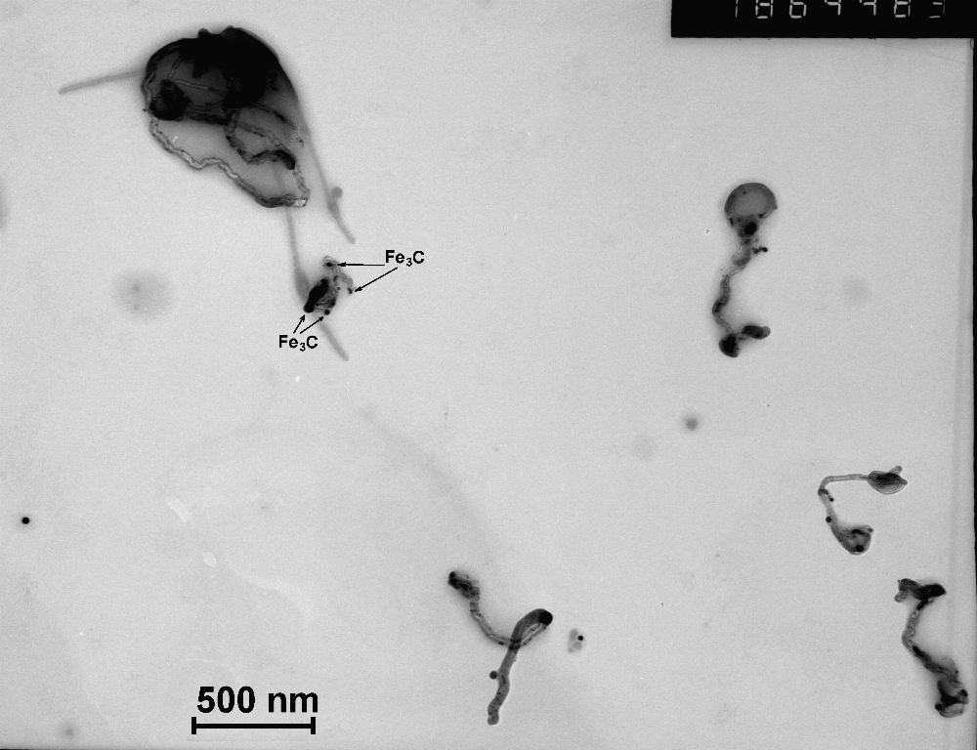
a

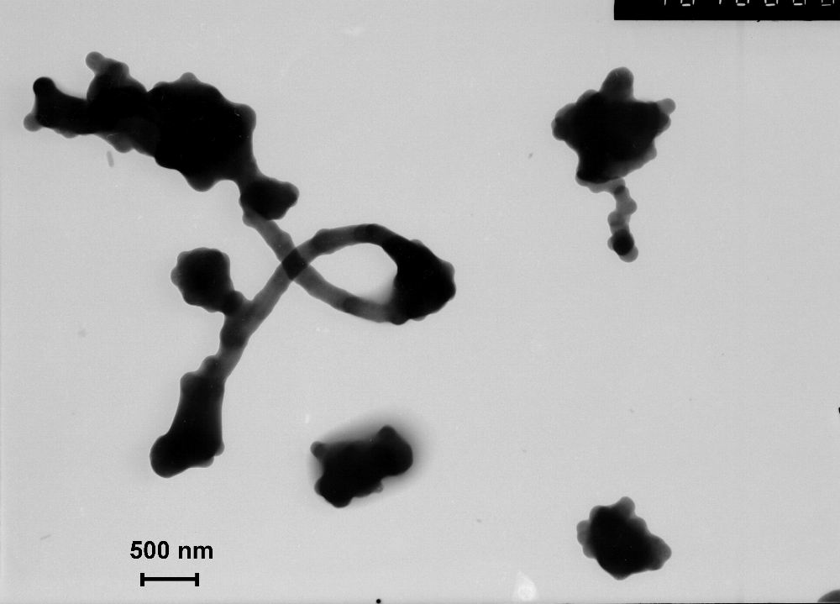
b

Fig. 4. TEM images of aerosol particles formed by co-pyrolysis of C₃H₈ and Fe(CO)₅ diluted by Ar; reaction temperature and initial molar fractions for propane f_{C3H8} and iron pentacarbonyl f_{Fe(CO)5} are respectively: a) T = 1173 K, f_{C3H8} = 5.8×10⁻³ and f_{Fe(CO)5} = 9.2×10⁻⁶; b) T = 1280 K, f_{C3H8} = 6.8×10⁻² and f_{Fe(CO)5} = 6.7×10⁻⁵.

Fig. 5. XRD spectrum from Fe₃C phase being a constituent of samples formed by co-pyrolysis of C₃H₈ and Fe(CO)₅ diluted by Ar; reaction temperature and initial molar fractions for propane f_{C3H8} and iron pentacarbonyl f_{Fe(CO)5} are respectively T = 1173 K, f_{C3H8} = 4.6×10⁻³ and f_{Fe(CO)5} = 1.4×10⁻⁴.

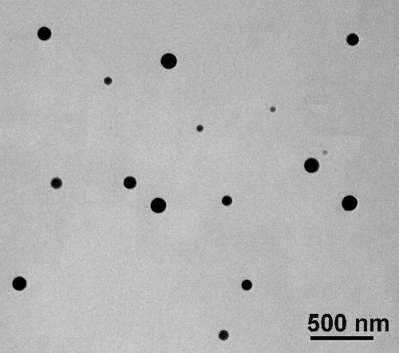

Fig. 6. TEM images of aerosol particles formed by pyrolysis of C₃H₈ +Ar mixrure; reaction temperature and initial molar fractions for propane f_{C3H8} are respectively T = 1173 K, f_{C3H8} = 1.34×10⁻³.

Fig. 7. Size distribution function for soot nanoparticles formed by pyrolysis of C₃H₈ +Ar mixrure (as measured by ADB); reaction temperature and initial molar fractions for propane f_{C3H8} are respectively T = 1173 K, f_{C3H8} = 1.34×10⁻³; N is number of particles of size less than d.

Fig. 8. Carbon radical EPR signal from a pumped soot sample; measurement temperature T = 300 K. Soot particles were formed by pyrolysis of C₃H₈+Ar mixture at temperature 1280 K. The propane inlet molar fraction f_{C3H8} = 6.7×10⁻².

Fig. 9. EPR signal from a soot sample; the measurement temperature T = 300 K. The sample test tube is filled by O₂ (20%)+ Ar (80%) mixture. The oxygen pressure is 7.4 Torr. Soot particles were formed by pyrolysis of of C₃H₈+Ar mixture at temperature 1280 K. The propane inlet molar fraction f_{C3H8} = 6.7×10⁻².

Fig. 10. Line width for the broad component of the soot EPR signal vs. oxygen pressure in the test tube; the measurement temperature T = 300 K. Soot particles were formed by pyrolysis of of C₃H₈+Ar mixture at temperature 1280 K. The propane inlet molar fraction f_{C3H8} = 6.7×10⁻².

Fig. 11. Line width for the broad component of the soot EPR signal vs. measurement temperature. The sample test tube is filled by O₂ (20%)+ Ar (80%) mixture. The oxygen pressure is 7.4 Torr. Soot particles were formed by pyrolysis of C₃H₈+Ar mixture at temperature 1280 K. The propane inlet molar fraction f_{C3H8} = 6.7×10⁻². Circles – slow cooling, diamond – quick cooling. Solid line is eye guide.

Fig. 12. Line width for the broad component of the soot EPR signal vs. time of heating. The sample test tube is filled by O₂ (20%)+ Ar (80%) mixture. The oxygen pressure is 7.4 Torr. Soot particles were formed by pyrolysis of of C₃H₈+Ar mixture at temperature 1280 K. The propane inlet molar fraction f_{C3H8} = 6.7×10⁻².

Fig. 13. EPR spectra from carbonaceous as-prepared samples formed by co-pyrolysis of C₃H₈ and Fe(CO)₅ diluted by Ar; reaction temperature is T = 1280 K; initial molar fractions for propane f_{C3H8} and iron pentacarbonyl f_{Fe(CO)5} are, respectively, f_{C3H8} = 6.0×10⁻² and f_{Fe(CO)5} = 1.8×10⁻⁵ (dash line); f_{C3H8} = 5.6×10⁻² and f_{Fe(CO)5} = 5.8×10⁻⁵ (solid line)

Fig. 14. EPR line width for carbon radicals from carbonaceous as-prepared samples formed by co-pyrolysis of C₃H₈ and Fe(CO)₅ diluted by Ar; reaction temperature T = 1280 K; initial molar fraction for propane f_{C3H8} = 6×10⁻². Evacuated test tube. Solid line is eye guide.

Fig. 15. EPR spectra from the sample formed by co-pyrolysis of C₃H₈ and Fe(CO)₅ diluted by Ar; reaction temperature T = 1280 K; initial molar fraction for propane and Fe(CO)₅ are f_{C3H8} = 6.0×10⁻² and f_{Fe(CO)5} = 1.8×10⁻⁵. 1 – exposed to air during 160 days (non-evacuated) N_{S} = 4×10¹⁸ g⁻¹, ΔB_{PP}=0.36 mT; 2 – exposed to air during 160 days (evacuated) N_{S} = 1×10¹⁹ g⁻¹, ΔB_{PP}= 0.12 mT.

