THE CHEMICAL COMPOSITION OF THE AEROSOL PARTICLE PRODUCING
BY THE FOREST FIRES IN SIBERIA

K.P. Koutsenogii^{1*}, V.I. Makarov¹, G.A. Kovalskaya¹,
A.I. Smirnova¹, B.S. Smolyakov², L.A. Pavlyuk²

¹ Institute of Chemical Kinetics and Combustion Siberian Branch of Russian Academy of Sciences,
630090, Institutskaya st. 3, Novosibirsk, Russia
Phone 7(3832)333753
email koutsen@ns.kinetics.nsc.ru
² Institute of Inorganic Chemistry, Siberian Branch of Russian Academy of Sciences, Novosibirsk, 630090, Russia

Keywords: atmospheric aerosols; ionic and multielemental composition; carbonaceous; biomass burning

Abstract

In this report present the data about the chemical composition of the aerosols producing by the forest fires in Siberia.

Introduction

Forest fires are a powerful source of environment pollution. The volume and composition of emissions depend on the type and amount of vegetation fuel, vegetation type, meteorological conditions, and combustion regimes. Due to the complexity and diversity of factors that influence the combustion products, so far there are no strict theoretical models which would make it possible to calculate the above mentioned characteristics by the initial data. That is why our knowledge of the structure, composition, particle size distribution and number concentration of aerosol formed in the process of biomass burning had been obtained as a result of rather complicated and expensive experiments in various forest vegetation zones.
To day the most complete data have been obtained in measuring aerosol characteristics burning of forests and savannas of the tropical zones. As to characteristics of aerosol formed in burning of forests at middle latitudes of the northern hemisphere and boreal forests they are scarce and fragmentary (Joel S. Levine, 1996).
The proximity of boreal forests to the Arctic region is extremely important also from the point of view of elucidation of the influence of the influence of biomass combustion processes on the climate, since this zone is the most sensitive to changes of climate conditions.
Approximated estimations show that every year about 10 million ha undergo fires in the territory of Siberia. As a result up to 20 million tons of biomass get burn during 4 – 5 months of fire-hazardous period. In the present paper data are presented on the amount and chemical composition of aerosol generated by forest fires. These data were obtained in 1993 during an international experiment of FIRESCAN – Fire Research Campaign Asia – North (J.G. Goldamer et al., 1996) and in 1997 during monitoring atmospheric aerosol in Novosibirsk region in frame of project “ Siberian Aerosol” (K.P. Koutsenogii, P.K. Koutsenogii, 1997).

Results

A large forest fire. The detail description of experimental site is in (G.J. Goldamer et al., 1996).
Samples of aerosols formed during combustion were collected from the smoke column at heights of 500 to 1500 m using four sampling devices mounted on an MI – 8 helicopter chassis (N.S. Bufetov et al., 1994).
The multielemental content of aerosol particles of different size was determined by X-ray – fluorescence (XRF) method then the characteristic spectrum excited by synchrotron radiation (SR). For sampling use two cascade virtual impactor divided the aerosol particles on two fraction. The first one was coarse particles (d>1 mkm), the second one was fine particles (d<1 mkm).
The method of determining the multielemental composition of aerosol by SRXRF analysis is described in (V.B. Baryshev et al., 1995). The impactor parameters were calculated according to method described in (B.W. Loo, C.P. Cork, 1988). The detailed experimental data represent in (N.S. Bufetov et al., 1994, K.P. Koutsenogii et al., 1996).
The Fig.1 shown the multielemental composition of coarse and fine the background atmospheric aerosol and the aerosol particles emitted by the large forest fire. On the vertical axis plotted an enrichment factor (EF_{i}) calculated by (1), (2)
EF_{i} = X_{i} _{ae r} / X_{i crust} (1)
X_{i} = C_{i} / C_{Fe} (2)
C_{i} – i-th element mass concentration
C_{Fe} – Fe mass concentration
The symbols “aer” and “crust” means the mass concentration in aerosol and earth core. The size, shape, number and mass concentration of aerosol particles was determined by scanning electron microscopy (SEM) analyzing the aerosol deposit on Nuclepore filter. The results of SEM analysis present in the Table 1.

C  L  A  S  S | Shape | Particle  size, mkm |  |  | Number concen-tration  n_{i}, m⁻³ | Mass concentration  m_{i}, mkg ⋅m⁻³
 |  | l_{i} | n_{i} | d_{i}
1 | Elongated,  fibrous | 130 | 35 |  | 700 | 90
2 | Elongated,  fibrous | 50 | 10 |  | 1,8⋅10⁵ | 700
3 | Angular-rounded |  |  | 2 | 8⋅10⁶ | 30
4 | Almost sphhercal |  |  | 0,4 | 2,7⋅10⁹ | 90

Table 1 The size, morphology and concentration of aerosol determined by SEM

The treatment of electron microscopic photographs was carried out according the following relations:
n_{i} = SN_{i} / Q i=1 – 4, (3)
Where n_{i}, Ni are number concentration (m⁻³) and deposit density (m⁻²) of particles of the i– th class, S is the filter surface (m²), Q is the total volume flowed through the filter (m³).
m_{i}=(π/4)⋅ρ_{i}⋅l_{i}⋅h_{i}²⋅n_{i} i=1,2 (4)
m_{i}=(π/6)⋅ρ_{i}⋅ d_{i}³⋅n_{i} i=3, 4 (5)

ρ_{i,}, m_{i}, l_{i}, n_{i}, d_{i} are density, mass concentration, length, width, diameter of the aerosol particle of i-th class.
Surface forest fire. At the beginning of October 1997 year arose a smog situation on greater territory of Western Siberia. This is a smog formation were generated by burning of woods, peat and straw in Novosibirsk in Novosibirsk's, and Tomsk's regions, Krasnoyarsk and Altai territories. In such a contingency we attempted to obtain data on changes of composition of aerosol particles for such components: total mass concentration (M), organic (C_{or}) and elemental (C_{e}) carbon, anionic
( NH₄⁺, Ca²⁺, Mg²⁺, Na⁺, K⁺ ) and cation (HCO₃⁻, Cl⁻, NO₃⁻, SO₄⁻) content , multielemental composition. The ionic and carbonaceous content have to be of great importance exert on the climate. Aerosol samplings were performed continuously during 30 days at the height of 3 m over the earth's surface, simultaneously or independently, in Klutchi-village (40 km to the south of Novosibirsk, from 1 to 30 October 1997), Karasuk-station (400 km to the South-West of Novosibirsk, from 4 October to 2 November 1997).
On Fig.2 represent the sampling sites in Novosibirsk region.
The aerosols were sampled on the glass fibre paper (Dassel 50 mm, Germany) with the volume flow rate of 1.8 m³ h⁻¹ for the Karasuk samples and 1.4 m³ h⁻¹ for the Klutchi ones. The duration of each sampling was 24 hours, the total air volume was 30-40 m³ per a filter. Simultaneously, the polymeric fibre filters (AFA-ChA, 20 cm², Russia) were used (13 m³ h⁻¹, 24 hours) in order to measure the concentration of some ions in the air.
A quarter of each glass filter was used to measure the quantities of organic and inorganic carbons. The method is based on a catalytic conversion of organic substances or black carbon to methane, followed by a gas-chromatography determination of methane by flame-ionization detector. A half of each polymeric filter and 3 ml of water were then used to extract the ions followed by the ion-chromatography determination.
On Fig. 3a drawn the daily variation NO3⁻ and SO₄²⁻ concentration in Karasuk. One square centimeter of each polymeric filter used to determinate the multielemental composition by SRXRF.
The similarly depends in Klutchi shown on Fig 3b. The mass concentration ratio different elements in aerosol sampling during forest fire and background period present on Fig. 3c. The blue column are results from Klutchi. The rose one are results from Karasuk.
The similarly ratio for total mass concentration, organic and elemental carbon, also ionic composition shown in Fig. 3d.
On the vertical axis of Fig.3c and Fig.3d plotted the ratio of the relative mass concentration i-th element (X_{i}) according (2) during fire period (X_{iFe})_{fire} to background value (X_{iFe})_{background}. The first magnitude is mean value of Xi for the time period when NO₃⁻ concentration is excess or equal to SO₄²⁻ one.
From these diagrams it is clear that for forest fire in the mass concentration any element in the aerosol chemical composition increase from 1,5 to 4,5 times. The concentration some ion may increase more height time.

Acknowledgments

Grant INTAS - 93 - 0182
Grant of Siberian Branch of Russian Academy of Sciences.

References

V.B. Baryshev, N.S. Bufetov, K.P. Koutsenogii et al. (1995), Nuclear Instruments and Methods in Physics Research, A359:297-301.
N.S. Bufetov, V.B. Baryshev, E.N. Valendik et al. (1994). International aerosol symposium. Atmospheric aerosols, 1, March 21-25, 1994, Moskow:30-42.
J.G. Goldamer, B.J. Stocks, V.V. Furiaev, E.N. Valendik et al.(1996). FIRESCAN Science Team. Fire in Ecosystems of Boreal Eurasia: The Bor Forest Island Fire Experiment Fire Research Campaign Asia – North (FIRESCAN). In: Biomass Burning and Global Change. Ed. By Joel S. Levine. The MIT Press Cambridge, Massachusetts. London, England.Vol.2, pp. 848-873
K.P. Koutsenogii, E.N. Valendik, N.S. Bufetov, V.B. Baryshev (1996). Emission of aerosol from large forest fire in Siberia. Siberian Ecological Journal 5(1).
K.P. Koutsenogii, P.K. Koutsenogii (1997). Monitoring of Chemical and Disperse Composition of Atmospheric Aerosol in Siberia. Chemistry for Sustainable Development, 5:429-442.
B.W. Loo, C.P. Cork (1998). Aerosol Science and Technology, 9:167-176.

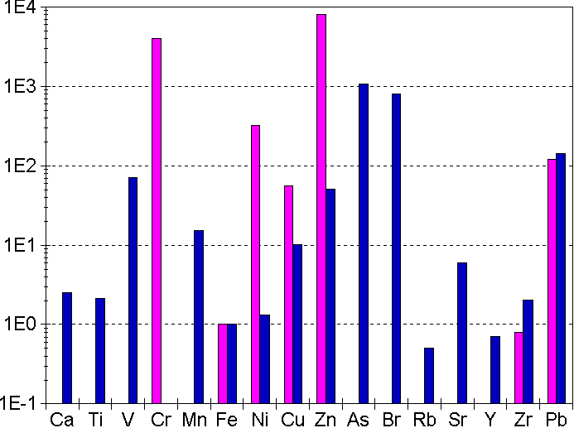
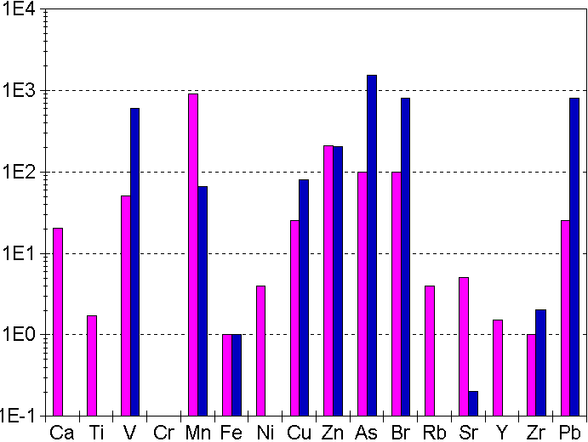

Coarse particles (d>1μm) | Fine particles (d<1μm)
Fig.1 Enriching factor for different elements in the background atmospheric aerosols (blue columns) and in the aerosols of smoke columns of the forest fire (rose columns)

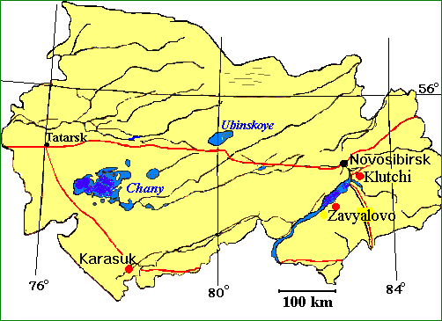
• - aerosol sampling site

Fig. 2 Map of Novosibirsk region

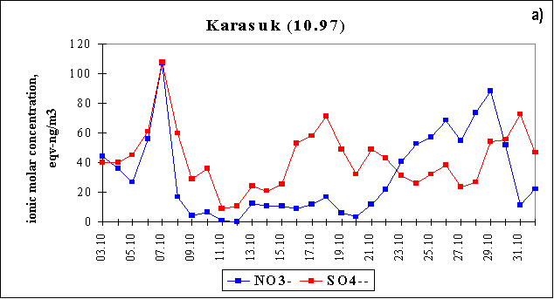
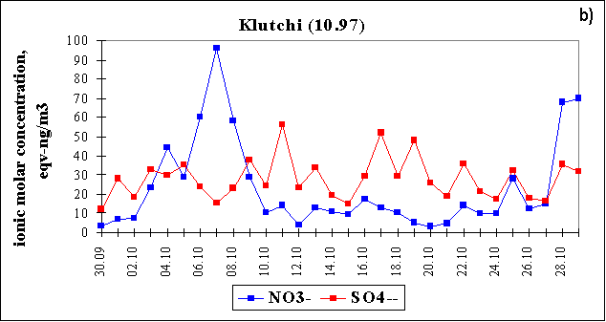
 | 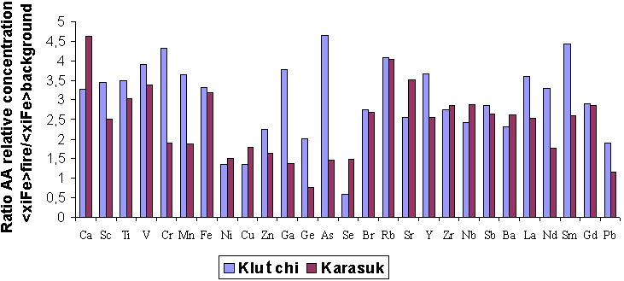  c) | c)
 | 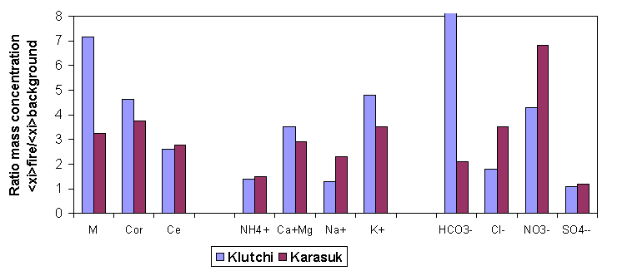  Cor - organic carbon  M-total mass concentration  d) | d)
 | Cor - organic carbon M-total mass concentration Ce - elemental carbon
 | Fig.3 The aerosol chemical composition during the surface forest fire

