Macro and Trace Elements, Mengen- und Spurenelemente. 21.Workshop. October, 18-19, 2002, Prossidings Book (Eds: Manfred Anke, U.Schafer, R.Muller) Main Bulding of the Friedrich Schiller University, Jena 2002, pp 364-370.

Ecological Consequence Wildland fire in Siberian Boreal Forest
¹Koutzenogii, K., ¹Samsonov, Yu., ¹Makarov, V., ¹Churkina, T., ²Ivanova, G., ²Ivanov, A., ³Conard, S., ³Baker, S., ³Hao, W, ⁴McRae, D, ¹Smirnova, A., ¹Kovalskaya, G., ⁵Smolyakov, B., ¹Chankina, O., ¹Savchenko, T.

¹Institute of Chemical Kinetics and Combustion of Siberian Brunch of the Russian Academy of Sciences, 630090 Novosibirsk, Russia
²V.N. Sukachev Institute of Forest of Siberian Brunch of the Russian Academy of Sciences, Krasnoyarsk, Russia
³USDA Forest Service, Washington, USA
⁴Canadian Forest Service, Great Lakes Forestry Center, Sault Ste. Marie, Canada
⁵Institute of Inorganic Chemistry of Siberian Brunch of the Russian Academy of Sciences, 630090 Novosibirsk, Russia

Forest fires are a powerful source of environment pollution. The volume and composition of emissions depend on the type and amount of vegetation fuel, vegetation type, meteorogical conditions, and combustion regimes. Due to the complexity and diversity of factors that influence the combustion products, so far there are no strict theoretical models which would make it possible to calculate the above mentioned characteristics by the initial data. That is why our knowledge of the structure, composition, particle size distribution and number concentration of aerosol formed in the process of biomass burning had been obtained as a result of rather complication and expensive experiments in various forest vegetation zones.
To day the most complete data have been obtained in measuring aerosol characteristics burning of forests and savannas of the tropical zones. As to characteristics of aerosol formed in burning of forests at middle latitudes of the Northern Hemisphere and boreal forests they are scarce and fragmentary. The proximity of boreal forests to the Arctic region is extremely important also from the point of view of elucidation of the influence of biomass combustion processes on the climate, since this zone is the most sensitive to changes of climate conditions.
Approximated estimations show that every year about 10 million ha fires in the territory of Siberia. As a result up to 20 million tons of biomass get burn during 4-5 months of fire-hazardous period. In the present paper data are presented on the amount and chemical composition of aerosol and gas emissions generated by forest fires also results of the determination of multielement composition of forest combustibles (FC) and soils before and after experimental fire in Siberian Boreal forests.
These data were obtained in 1993 during an International experiment of FIRESCAN – Fire Research Campaign Asia – North (Goldamer J. 1996) and in 1997 during monitoring atmospheric aerosol in Novosibirsk region in frame of project “Siberian Aerosol” (Koutsenogii K. and Koutsenogii P. 1997). The emissions were sampled during fire experiments in 2000-2001 in the frame work of International Project “Effects of Fire in Boreal Forests of Russia”. The samples Forest combustible (FC) and soil were collected from the experimental region in 2000-2001.

Materials and Methods
The detail description of experimental site is in (Goldamer J. et al 1996). Samples of aerosols formed during combustion were collected from the smoke column at heights of 500 to 1500 m using four sampling devices mounted on an MI – 8 helicopter (Bufetov, N. et al 1994). For sampling use two cascades virtual impactor divided the aerosol particles on two fractions. The first one was coarse particles (d>1 mkm), the second one was fine particles (d<1mkm). Aerosol emissions were sampled by pumping fire smokes through filters made from either glass fibre or polimeric fibre materials. Gaseons emissions, namely, carbon dioxide (CO2), carbon oxide (CO) as well as other gaseons species were sampled into the pre-evaluated or metallic glass bottles.
To analyses mass concentration and chemical composition gas and aerosol emissions used different analytical methods: gravimetric (aerosol mass concentration), gas-liquid chromatography (mass concentration gaseous), reactivity gas-liquid chromatography (organic and elemental carbon mass concentration), ionic chromatography (ionic composition), synchrotron radiation X-ray fluorescence (SRXRF) (multielement composition).
The samples of forest combustibles include 12 types: moss, lichen, wild rosemary, bilberries, leaves and twigs of cowberry, pine cones, pine needles and bark, etc. The soil samples were collected from the experimental region in the settlement Yartzevo before and after test burning. Two soil profiles were obtained in the region where moss (mossy sinusiya) and lichen (lichen sinusiya) prevail. The dry FC, soil and incompletely burnt samples were carefully grinded in an agate mortar and pressed into tablets with a 1cm diameter, a weight of 20 to 50 mg. Multielement composition of samples was determined by SRXRF (Baryshev V. et al 1986). The analytical method without standard Reference materials for biological samples with a light matrix was used to quantitatively interpretation the results of measurement of line intensities of the characteristic spectrum. As a standard, we used a uniform thin standard (Baryshev V. et al 1995).

Results
The Fig 1 shows the multielement composition of coarse and fine the background atmospheric aerosol and the aerosol particles emitted by the large forest fire. On the vertical axis plotted an enrichment factor (E_{fi} ) calculated by (1), (2)
E_{fi} = X_{i} _{aer} / X_{i} _{crust} (1); X_{i} = C_{i} / C_{Fe} (2), C_{i} – i-th element mass concentration, C_{Fe} – Fe mass concentration. The symbols “aer” and “crust’ means the mass concentration in aerosol and earth core.

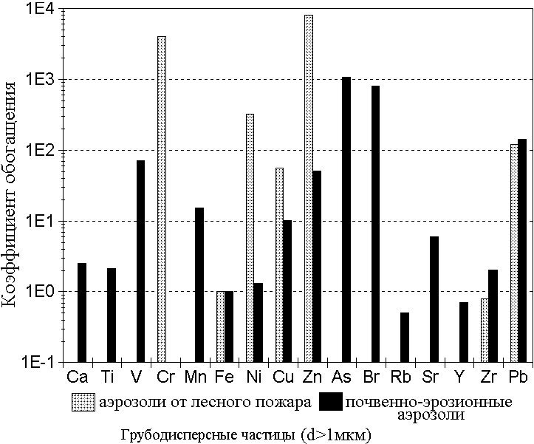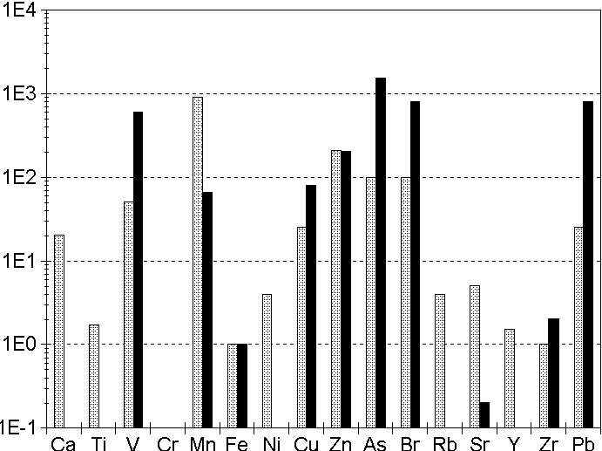
Coarse particles (d>1μm) | Fine particles (d<1μm)

Fig.1. Enriching factor for different elements in the background atmospheric aerosols (black columns) and in the aerosols of smoke columns of the forest fire (light columns).

At the beginning of October 1997 year arose a smog situation on greater territory of Western Siberia. This is a smog formation were generated by burning of woods, peat and straw in Novosibirsk, Krasnoyarsk, Tomsk and Altai territories. In such a contingency we attempted to obtain data on changes of composition of aerosol particles for such components: total mass concentration (M), organic (C_{or}) and elemental (C_{e}) carbon, anionic (NH₄⁺, Ca⁺², Mg⁺², Na+, K⁺) and cations (HCO3⁻, Cl⁻, NO₃⁻, SO₄⁻) content. The ionic and carbonaceous content have to be of great importance exert on the climate. Aerosol sampling were performed continuously during 30 days at the height of 3 m over the earth's surface, simultaneously or independently, in Klutchi-village (40 km to the south of Novosibirsk, from 1 to 30 October 1997), Karasuk-station (400 km to the South-West of Novosibirsk, from 4 October to 2 November 1997).
The mass concentration ratio different elements in aerosol sampling during forest fire and background period present on Fig 2a. The black columns are results from Klutchi. The light one are results from Karasuk. The similarly ratio for total mass concentration, organic and elemental carbon, also ionic composition shown in Fig 2b. On the vertical axis of Fig 2a and Fig. 2b plotted the ratio of the relative mass concentration i-th element (X_{iFe}) fire to background value (X_{iFe}) background. From these diagrams it is clear that for forest fire in the mass concentration of chemical composition increase from 1,5 to 4,5 times. The concentration some ion may increase more height time.
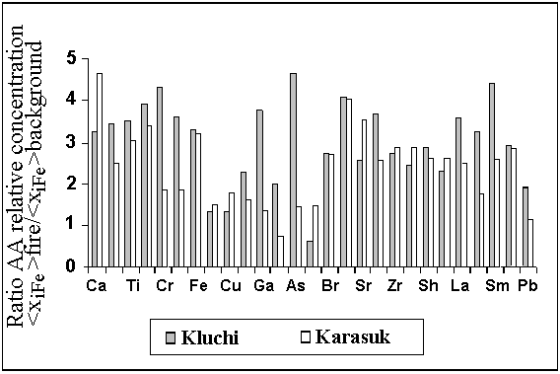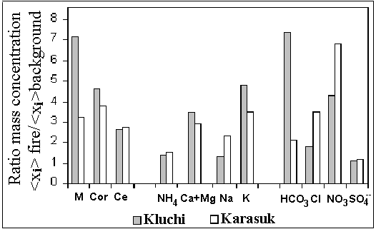
a b

Fig 2 The aerosol chemical composition during the forest fire
The experimental data was shown that on first step the relationship between different components of the gas and aerosol emissions might be approximated by linear function. These relationships illustrate Fig 3. On the Fig present correlation between CO₂ (dioxide carbon) and CO (oxide carbon) depend on different type experimental plots. Upper figure is as example the tight relationship. The lower part Fig demonstrates correlation between the result received in different laboratories. Because the oxide carbon (CO) emission measurement is the more assurance we used the ratio mass concentration different species to oxide carbon (CO) concentration as the reference. Thus, this one is characteristic of chemical composition gas and aerosol emissions. On Fig 4 can see correlation between methane (CH₄) and oxide carbon (CO) concentrations. The ratio different gaseons species to oxide carbon (CO) measured on the ground and helicopter present in table1 (Gas Emission Chemical Composition).
Name | Formula | Ratio C_{i}/C_{CO},%
Ground Emission
Methane | CH₄ | 3,2 - 5,7
Ethylene | C₂H₄ | 0,73 -0,87
Acetylene | C₂H₂ | 0,09 - 0,16
Ethane | C₂H₈ | 0,33 - 0,38
Propylene | C₃H₆ | 0,08 - 0,18
Propane | C₃H₈ | 0,07 - 0,12
Helicopter Sampling
Hydrogen | H₂ | 9,7-14
Benzene | C₆H₆ | 0,011
Methane | CH₄ | 2,4 - 5,1
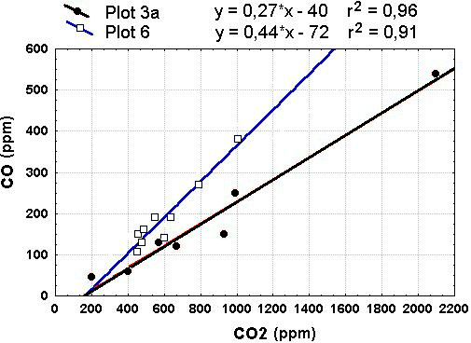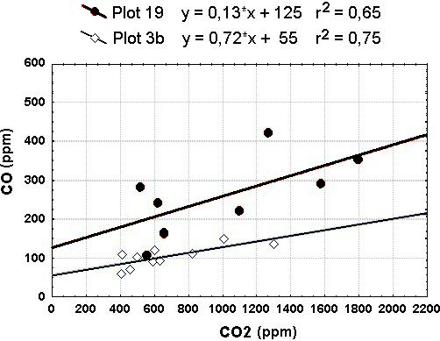
Fig.3. Siberia 2001 Ground Emission CO vs.CO₂

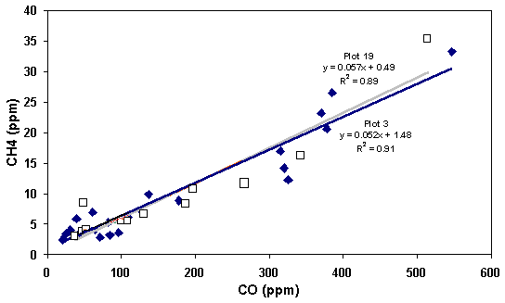
Fig.4. Siberia 2001 Ground Emission Methane vs.CO

The chemical composition aerosol emission measured in 2001 years present on Fig 5.
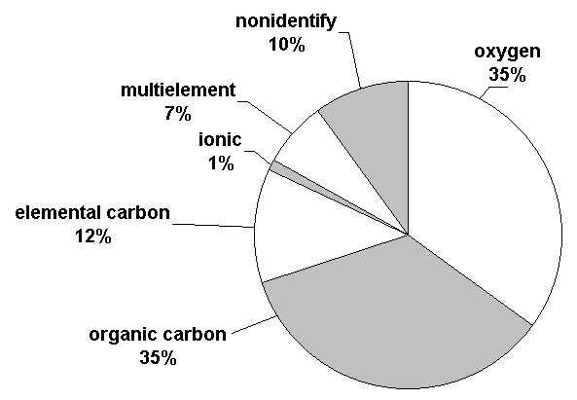
Fig.5. The chemical composition aerosol emission measured in 2001 years

From this diagram we can see that more abundance component is organic substance. On 2001 was seventy percent (70%). The ratio change organic to element carbon concentration from three (3) to three and half (3,5) times. Ionic concentration was one percent (1%) and multielement one seven percent (7%). On 2000 year did not identify sixty and five percent (65%). On 2001 year did not near ten percent (10%).

Table 2 compares the multielement compositions of different types of soils before and after fires for topsoil. The forest fire is observed to have different effects on the content of elements in topsoil various kinds soil. An increase in concentration for most elements (17) after experimental burning occurred for the soils of lichen sinusiya. It is yet difficult to conclude whether the microbiocenosis type or fire intensity has greater effect on these changes.

Table 2. Change in element composition of soils before and after the test burning, mkg/g
Elements | Mossy sinusiya |  |  | Lichen sinusiya
 | X₁ | X₂ | X₂ / X₁ | X₁ | X₂ | X₂ / X₁
K | 708 | 1000 | 1.4 | 325 | 790 | 2.4
Ca | 920 | 250 | 0.28 | 98 | 280 | 2.8
Ti | 360 | 200 | 0.56 | 126 | 234 | 1.9
V | 16 | 5 | 0.3 | 5.3 | 21 | 4
Cr | 3.2 | 31 | 9.7 | 4.5 | 11 | 2.4
Mn | 28 | 16 | 0.6 | 4.1 | 39 | 9.3
Fe | 937 | 490 | 0.5 | 320 | 370 | 1.2
Co | 5 | 3.4 | 0.6 | n.s. | 0.5 | X₂>
Ni | 2.4 | 3.2 | 1.3 | 1.1 | 1.0 | 0.9
Cu | 4 | 3 | 0.75 | 2.7 | 2.7 | 1
Zn | 4.8 | 4.4 | 0.9 | 4.3 | 3.4 | 0.8
Ga | 2 | 1.7 | 0.8 | 1.3 | 1.0 | 0.8
Ge | 0.5 | 0.9 | 1.8 | 0.1 | 0.5 | 5
As | n.s. | 0,2 | X₂> | 0.3 | 19 | 64
Se | 0.3 | 0.5 | 1.4 | 0.4 | 0.5 | 1.2
Br | 0.7 | 1.4 | 2 | 0.7 | 0.6 | 0.9
Rb | 9.8 | 13.5 | 1.4 | 6,4 | 8,2 | 1,4
Sr | 18 | 20 | 1.1 | 8,1 | 13 | 1,6
Y | 1.7 | 1.7 | 1 | 0.4 | 1.6 | 4
Zr | 23 | 55 | 2.4 | 11 | 78 | 7.1
Ba | n.s. | 46 | X₂> | 7.2 | n.s. | X₂<
Hg | 0.7 | 0.3 | 0.46 | 0.6 | 0.4 | 0.7
Pb | 2.8 | 2.8 | 1 | 1 | 5.8 | 5.8
Bi | 0.5 | 0.6 | 1.2 | 0.6 | 0.25 | 0.4
Th | 0.5 | 0.2 | 0.4 | n.s. | 0.18 | X₂>
X₁, X₂ – element concentrations of soils before and after experimental burning; n.s. – no significance
Table 3 shows a change in the content of elements in the forest combustion (FC) before and after the burning of the experimental region. A comparison shows that the burning causes a substantial increase in the concentrations of the elements determined. That is bound up with the burning of the organic FC component and the concentration of the mineral part elements, obviously. A weaker difference is observed for the betting.
Table 3. Multielement composition of forest combustibles and their condensed combustion materials, mkg/g
Element | Ashes (moss, lichen) |  | Charred twig (<5mm) |  | Bedding
Element | Before burning | After burning | Before burning | After burning | Before burning | After burning
K | 1600 | 8900 | 180 | 3300 | 1100 | 1900
Ca | 3600 | 3700 | 1000 | 17000 | 3600 | 6200
Ti | 52 | 430 | 17 | 290 | 300 | 460
Cr | 3,7 | 46 | 3,2 | 23 | 13 | 37
Mn | 490 | 4600 | 140 | 2300 | 480 | 660
Fe | 440 | 2400 | 200 | 1600 | 1800 | 2100
Co | 1,8 | 12 | 0,5 | 8,9 | 9,6 | 12
Cu | 3.2 | 31 | 2,4 | 19 | 8,6 | 79
Zn | 31 | 200 | 15 | 120 | 54 | 160
Ga | 0,4 | 2,1 | 0,4 | 1,5 | 1,2 | 1,8
Br | 2,4 | 7,7 | 1,7 | 5,3 | 10 | 11
Rb | 8.2 | 31 | 1,0 | 13,0 | 8,6 | 10
Sr | 9,5 | 66 | 5,2 | 32 | 22 | 22
Zr | 2,5 | 11 | 0,5 | 9,3 | 6,3 | 13
Pb | 3 | 21 | 3,8 | 15 | 17 | 22
Bi | 0,1 | 0,3 | 0,3 | 0,5 | 0,5 | 0,4
Th | 0,08 | 0,8 | n.s. | 0,3 | 0,2 | 0,3

Conclusions

The method to determinate the intensity of gas and aerosol emissions from forest fire was designed.
In time experimental fire in Siberian Boreal forest using this method was measured the mass concentration and composition gas (CO₂, CO, CH₄, C₂H₂, C₃H ₆, C₇,H₁₄) and aerosol (elemental and organic carbon, ionic and multielement components) emissions.
These results may be the basis to calculate gas and aerosol emissions from Boreal forest fire and evaluate the consequences on the ecosystems Boreal forest.
It was received primary data about the relation between the combustion regime and the type of forest fuel.
A comparison between the chemical contents of forest combustibles and the condensed products of burning as well as between the changes in the chemical composition of soils is important for estimating the ecological effect of forest fires on the plants and soil of forest biocenosis.

References
1.Baryshev, V., Bufetov, N., Koutsenogii, K., Makarov, V., Smirnova, A. (1995): Nucl. Instr. and Meth. A 359, 297-301.
2. Barushev, V., Kulipanov, G., Skrinsky, A. (1986): Nucl. Instr. and Meth. A 246, 739-750.
3. Bufetov, N., Baryshev, V., Valendik, E. et al. (1994): In: International aerosol symposium. Atmospheric aerosols, 1 March 21-25, Moskow, 30-42.
4. Goldamer, J., Stocks, B, Furiaev, V.,Valendik, et al. (1996): In: Biomass Burning and Global Change. Ed.by Joel S. Levine. The MIT Press Cambridge, Massachusetts. London, England. Vol. 2, pp. 848-873.
5. Koutsenogii, K., Koutsenogii, P. (1997): Chemistry for Sustainable Development, 5, 429-442.

Key Words: Atmospheric aerosol; Emission; Elemental composition; Forest fire; SRXRF.

