A COMPARATIVE, TWO-DIMENSIONAL ¹⁴N ESEEM CHARACTERIZATION OF REDUCED [2Fe-2S] CLUSTERS IN HYPERTHERMOPHILIC ARCHAEAL HIGH- AND LOW-POTENTIAL RIESKE-TYPE PROTEINS

Sergei A. Dikanovª, Alexander A. Shubin^{b}, Asako Kounosu^{c},
Toshio Iwasaki^{c}, Rimma I. Samoilova^{d}

ªDepartment of Veterinary Clinical Medicine, University of Illinois at Urbana-Champaign,
Urbana IL 61801, USA
^{b}Boreskov Institute of Catalysis, Russian Academy of Sciences, Novosibirsk 630090, Russia
^{c}Department of Biochemistry and Molecular Biology, Nippon Medical School, Sendagi, Bunkyo-ku, Tokyo113-8602, Japan
^{d}Institute of Chemical Kinetics and Combustion, Russian Academy of Sciences,
Novosibirsk 630090, Russia

: Fax: (217) 333 8868, e-mail: dikanov@uiuc.edu

Abstract

Proteins of the Rieske and Rieske-type family contain a [2Fe-2S] cluster with mixed ligation by two histidines and two cysteines and play important roles in various biological electron transfer reactions. We report here the comparative orientation-selected ESEEM and HYSCORE studies of the reduced clusters from two hyperthermophilic Rieske-type proteins; a high-potential, archaeal Rieske protein called sulredoxin (SDX) from Sulfolobus tokodaii with weak homology to the cytochrome bc-associated Rieske proteins, and a low-potential, archaeal homolog of an oxygenase-associated Rieske-type ferredoxin (ARF) from Sulfolobus solfataricus. ¹⁴N ESEEM and HYSCORE spectra of SDX and ARF show well-defined variations, which are primarily determined by changes of quadrupole couplings (up to 50% depending on the selected orientation) of the two coordinated nitrogens. These are due to variations in coordination geometry of the histidine imidazole ligands rather than to variations of hyperfine couplings of these nitrogens, which do not exceed 8-10%. The measured quadrupole couplings and their differences in the two proteins are consistent with ones calculated using the reported crystal structures of high- and low-potential Rieske proteins. These results suggest that exploration of quadrupole tensors might provide a more accurate method for characterization of the histidine coordination in different proteins and mutants than hyperfine tensors, and might have potential applications in a wider range of biological system.

Key words: Rieske protein, reduced [2Fe-2S] cluster, electron spin echo envelope modulation (ESEEM), hyperfine sublevel correlation (HYSCORE), archaea.

Abbreviations: ARF, archaeal low-potential Rieske-type ferredoxin from Sulfolobus solfataricus; E_{m}, midpoint redox potential; dq, double-quantum; ENDOR, electron nuclear double resonance; EPR, electron paramagnetic resonance; ESEEM, electron spin echo envelope modulation; hfi, hyperfine interaction; HYSCORE, hyperfine sublevel correlation; N1_{SDX/ARF} and N2_{SDX/ARF}, two coordinated N_{δ} in SDX and ARF; nqi, nuclear quadrupole interaction; SDX, archaeal high-potential Rieske protein from Sulfolobus tokodaii; sq, single-quantum; 1D, one-dimensional; 2D, two-dimensional.

Electronic Supplementary Material Supplementary Material is available for this article.

Introduction
Proteins containing Rieske-type [2Fe-2S] clusters are widespread in nature from archaea and bacteria to eukarya, and play critical electron transfer roles in various key pathways such as aerobic respiration, photosynthesis, and biodegradation of some alkene and aromatic compounds [1-4]. In contrast to regular plant- and vertebrate-type ferredoxins having complete cysteinyl ligations, the Rieske-type cluster has an asymmetric iron-sulfur core with the Sγ atom of each of the two cysteine residues coordinated to one iron site and the N_{δ} atom of each of the two histidine residues coordinated to the other iron site. This asymmetric ligation results in some unique redox and spectroscopic properties [reviewed in 1,3-5]. Recent site-directed mutagenesis studies [6] indicate that the electronegativity of the terminal ligands (histidine versus sulfur), as well as the overall charge of the Rieske-type [2Fe-2S] cluster, contribute significantly to the higher reduction potentials of these proteins compared to those in regular plant- and vertebrate-type [2Fe-2S] ferredoxins.
Two different types of Rieske clusters are observed in proteins. One type displays higher reduction potentials (Em) of ~ +150 - +490 mV and occurs in proton-translocating respiratory complexes (cytochrome bc1/b6f complexes and their archaeal homologs without c-type cytochromes), being involved not only in electron transfer, but also in substrate binding and oxidation at the quinol-oxidizing Qo-site [2-5, 7-10]. The other type displays lower Em of ~ -150 to -50 mV and has been found in a diverse group of archaeal and bacterial multicomponent terminal oxygenases and soluble Rieske-type ferredoxins [1,3,11-22].
Evidence for the histidine ligands in the Rieske-type cluster was first obtained by ENDOR [15,16] and ESEEM [23,24]. Gurbiel et al. have performed a detailed ¹⁵N Q-band ENDOR study of two Rieske proteins. They found that hyperfine tensors of coordinated N_{δ} were effectively the same, and proposed a structural model of histidine coordination to [2Fe-2S] cluster, which was assumed to be similar for all Rieske-type proteins. Crystal structures of Rieske and Rieske type proteins reported after these spectroscopic studies confirmed the presence of two histidine ligands [11,25-27], but were not fully consistent with the model of ligand geometry based on the ENDOR-determined hyperfine tensors. Crystal structures also showed variations in the coordination geometry of histidine ligands, which we will discuss in detail in this paper.
On the other hand, recent orientation-selected 1D and 2D ESEEM studies of the reduced Rieske-type clusters in benzene-1,2-dioxygenase [17], 2,4,5-trichlorophenoxyacetate monooxygenase [18], and cytochrome bc₁ complex with different occupants of the quinol-oxidizing Q_{o}-site [10] showed clear differences among the spectra from ¹⁴N nitrogens in the surroundings of the low- and high-potential clusters that also appear to be in contradiction with the ENDOR-based conclusion about similarity of the Rieske center structure in different proteins. No adequate explanation for the origin of these differences has been proposed. The specific aim of this work is to establish the sources producing differences in the ¹⁴N ESEEM spectra of the Rieske cluster and to evaluate them for structural studies.
For this purpose, we herein report the comparative, orientation-selected 1D and 2D ESEEM characterization of the reduced Rieske-type [2Fe-2S] clusters in high- and low-potential Rieske-type proteins from the hyperthermoacidophilic archaeal genus Sulfolobus. The proteins of interest are the high-potential sulredoxin (SDX) from Sulfolobus tokodaii strain 7 (Em,acid pH of ~ +190 mV), which is weakly homologous to the cytochrome bc1-associated, high-potential Rieske proteins (DDBJ accession number, AB023295) [28-30], and the low-potential, archaeal Rieske-type ferredoxin (ARF) from Sulfolobus solfataricus strain P-1 (Em,7 of ~ -62 mV), which has the canonical cluster-binding motif for the low-potential proteins (DDBJ accession number, AB047031) [6,22]. These archaeal proteins have been overproduced in Escherichia coli, in which background they can be modified by site-directed mutagenesis, and can be obtained as highly concentrated samples suitable for spectroscopic studies [6,30,31]. At these high concentrations the intense EPR signals from reduced Rieske clusters allow collection of high quality 1D and 2D ESEEM spectra, both near the canonical directions of the g-tensor, and at intermediate fields within EPR line [30].
All previous ESEEM investigations of Rieske proteins were focused on analysis of the hyperfine couplings of coordinated nitrogens along the principal directions of the g-tensor, and demonstrated their high stability, but no attempt was made to correlate the spectra obtained with real structural differences. In this work, we explain, for the first time, that the hyperfine tensors of coordinated nitrogens are not sensitive to variations of histidine coordination, and we highlight the nuclear quadrupole interactions (nqi) as a more appropriate source of information on the coordination geometry of the hisitidine ligands. We also report measurement of quadrupole couplings along principal directions of the g-tensor for coordinated N_{δ}, which vary significantly between the two proteins and have a major influence on ¹⁴N ESEEM spectra. Experimental variations of quadrupole couplings were consistent with the calculated ones for high and low potential Rieske proteins with known structure. These findings allow us to propose the use of nitrogen nqi tensors for characterization of structural features in the immediate cluster environment, which are of importance in the reaction mechanism of high- and low-potential Rieske-type proteins. This approach has a general impact on proteins with nitrogen coordinated metal centers.

Experimental
Samples Preparation. Escherichia coli strain DH5α and strain HB101 (TaKaRa) used for cloning were grown in LB or TB medium, with 50 μg/ml ampicillin when required. Plasmids pGEMT and pGEM3Zf(+) (Promega) were used for cloning and sequencing. The expression vector pET28a was purchased from Novagen. Water was purified by a Milli-Q purification system (Millipore). Other chemicals mentioned in this study were of analytical grade.
The arf gene coding for the low-potential, archaeal Rieske-type ferredoxin (ORF c06009; DDBJ accession number AB047031) of S. solfataricus strain P-1 (DSM 1616T) and the sdx gene coding for the high-potential, archaeal sulredoxin (DDBJ accession number, AB023295) of S. tokodaii strain 7 (JCM 10545T; formerly Sulfolobus sp. strain 7 [32]) have been cloned, sequenced, and heterologously overexpressed in E. coli as reported elsewhere [6,22]. The recombinant holoproteins having a hexahistidine-tag at the N-terminus were purified as reported previously [6,22,33]. When required, the recombinant holoprotein was further purified by a Sephadex G-50 gel filtration column (Amersham Pharmacia Biotech).
Freshly prepared proteins were concentrated by pressure filtration with an Amicon YM-10 membrane. Further concentration was achieved by placing the samples under a stream of dry argon gas. The resulting samples (~0.5-1 mM) containing ~20% (v/v) glycerol were carefully transferred to the suprasil quartz EPR tubes (Wilmad) and reduced with sodium dithionite under argon, prior to freezing in liquid nitrogen.
EPR experiments. Pulsed EPR measurements were carried out using an X-band Bruker ELEXSYS E580 spectrometers with an Oxford CF 935 cryostat at 10-11 K. Several types of ESEEM experiments with different pulse sequences were employed, with appropriate phase cycling schemes to eliminate unwanted features from experimental echo envelopes. Among them are two pulse and 1D and 2D three- and four-pulse sequences. In the two pulse electron spin echo (ESE) experiment (/2----echo), intensity of the echo signal at a fixed interval, , between two microwave pulses with spin vector rotation angles /2 and  is measured as a function of magnetic field. In the 1D three-pulse experiment (/2--/2- T-/2--echo), the intensity of the stimulated echo signal after the third pulse is recorded as a function of time, T, at constant time, . The set of three-pulse envelopes recorded at different  values forms a 2D three-pulse data set. In the 2D four-pulse experiment (/2--/2-t₁--t₂-/2--echo, also called HYSCORE), the intensity of the stimulated echo after the fourth pulse was measured with variation of t₂ and t₁ whilst  remained constant. The length of a π/2 pulse was nominally 16 ns and a π pulse – 32 ns. The repetition rate of pulse sequences was 1000 Hz. HYSCORE data were collected in the form of 2D time-domain patterns containing 256×256 points with a step16 ns. Spectral processing of three- and four-pulse ESEEM patterns, including subtraction of relaxation decay (fitting by polynoms of 3-4 degree), apodization (Hamming window), zero feeling, and fast Fourier transformation (FT), was performed using Bruker WIN-EPR software.
Nitrogen ESEEM and HYSCORE. The three-pulse ESEEM experiment detects nuclear frequencies of the magnetic nuclei interacting with the unpaired electron of the reduced cluster. Each ¹⁴N with nuclear spin I=1 is characterized by six nuclear frequencies corresponding to two single-quantum (sq) and one double-quantum (dq) transitions from two electron spin manifolds m_{S} = ±1/2 (Fig. 1). However, some of these transitions could be formally forbidden and have a negligible intensity in the spectra of oriented systems. This phenomenon depends upon the strength of nuclear Zeeman, hyperfine and quadrupole interactions, and their relative orientation in the g-tensor coordinate system. In an orientation-disordered system an additional factor influencing the intensity of the different transitions is their orientation dependence. Strong orientation dependence of some transitions often prevents the appearance of observable lines with well-pronounced maxima.
The general advantage of the two-dimensional HYSCORE technique lies in the creation of non-diagonal cross-peaks whose coordinates are nuclear frequencies from opposite electron spin manifolds. ¹⁴N nucleus can produce up to 18 cross-peaks in each of two quadrants, (++) and (+−), of the HYSCORE spectra including two [dq${}_{±}$, dq${}_{∓}$] , eight [dq${}_{±}$ - sq^{(1,2)}${}_{∓}$], and eight [sq^{(1,2)}${}_{±}$ - sq^{(1,2)}${}_{∓}$] correlations [18]. However, again, only some of the possible cross-features had observable intensity. Those cross-peaks are distributed in two quadrants, (++) and (+−), depending on the relative values of nuclear magnetic interactions and orientation dependence of nuclear frequencies. In addition, the intensity of cross-peaks is significantly influenced by the time τ between the first and second pulses, which is kept constant in each HYSCORE experiment. Due to this property, several measurements at different times τ are usually required for the detection of all cross-peaks contributing to the spectra. Moreover, the ESEEM intensity of the nuclear transition and the intensity of cross-peaks involving this transition are described by different coefficients. As a result, the absence of the line from some transitions in three-pulse ESEEM spectra does not rule out the existence of the cross-peaks. HYSCORE also possesses an enhanced capability to detect peaks of low intensity relative to the three-pulse spectra. This experiment separates overlapping peaks along a second dimension and enhances the signal-to-noise ratio by the second FT. Observation of a few cross-features from ¹⁴N is often enough for the construction of its nuclear frequencies in both manifolds. These frequencies are used for calculating the nitrogen hyperfine and quadrupole couplings.
The first-order expressions for the ¹⁴N frequencies of the dq and sq transitions in the two electron spin manifolds in the case of dominating hyperfine interaction are equal to [15,34]:
ν_{1sq±} = A_{1n}/2 ± ν_{I} + 3Q_{n}/2
ν_{2sq±} = A_{1n}/2 ± ν_{I} − 3Q_{n}/2 (1)
ν_{dq±} = A_{1n} ± 2ν_{I}
where ν_{I} – Zeeman frequency, A_{1n} – hyperfine, and Q_{n} – quadrupole coupling at an arbitrary orientation of the external magnetic field in the selected coordinate system.
The second-order contributions to nuclear frequencies are equal to [34]:
ν⁽²⁾_{(1,2)sq+} = (A⁽²⁾ ±Q⁽²⁾)/(A_{n} −2ν_{I} )
ν⁽²⁾_{(1,2)sq-} = (A⁽²⁾ ±Q⁽²⁾)/(A_{n} +2ν_{I} ) (2)
ν⁽²⁾_{dq±} =A⁽²⁾ /(A_{n}/2 ±ν_{I} )
where
A⁽²⁾ =1/4(T²_{np} + T²_{nq}) +K²(3+η²) –3/4 Q²_{n}
Q⁽²⁾ =3(Q_{np}T_{np}+ Q_{nq}T_{nq})
The matrix T in A⁽²⁾ and Q⁽²⁾ represents the anisotropic part of the hyperfine interaction, n determines the orientation of the external magnetic field, and p and q are two orientations perpendicular to n and to each other. For instance, for the spectra measured at fields corresponding to g_{z} and g_{x} the principal values of the g-tensor; n is coincident with corresponding principal directions Z and X. Respectively, p and q are coincident with the two other remaining axes X and Y, Y and Z. K=e²qQ/4h is the quadrupole coupling constant, and η is the asymmetry parameter.
The second-order corrected hyperfine coupling A_{n} - could be determined from experimental frequencies of dq transitions using the equation [34]:
A_{n} = 2ν_{I}(ν_{dq+} + ν_{dq-} )/[8ν_{I} –(ν_{dq+} - ν_{dq-} )] (3)

Results
EPR spectra of the reduced clusters. Orientation selection. Strong antiferromagnetic coupling between the electron spins of two irons in [2Fe-2S] cluster via bridging sulfide atoms produces an EPR silent ground state in the oxidized Fe³⁺(S=5/2)-Fe³⁺(S=5/2) form of the cluster and paramagnetic S=1/2 ground state of the reduced form Fe³⁺(S=5/2)-Fe²⁺(S=2) [3]. Dithionite-reduced Rieske-type [2Fe-2S] clusters in SDX and ARF show typical EPR spectra from a rhombic g tensor, with principal values g_{z}=2.008, g_{y}=1.91, g_{x}=1.79 and g_{z}=2.02, g_{y}=1.90, g_{x}=1.81, respectively. The field-sweep two-pulse ESE spectra of SDX and ARF measured at the time τ=300 ns are shown in Fig. 2. The width of the anisotropic EPR spectra of the reduced Rieske-type [2Fe-2S] clusters is ~40-50 mT, which significantly exceeds the spectral interval excited by microwave pulses (~0.5-1 mT). The ESEEM and HYSCORE measurements under such conditions are orientation-selective experiments, because the magnetic field fixed at any point within the EPR line selects clusters with different orientations of the g-tensor relative to the magnetic field direction. Thus, the ESEEM and HYSCORE spectra taken at the high and low extreme edges near the maximal and minimal g values (Fig. 2) give “single-crystal-like” patterns from the reduced clusters, whose g_{z} and g_{x} axes are directed along the magnetic field. The ¹⁴N nuclear frequencies, determined from such spectra and treated with Eqs. (1-3), can provide an estimate of the diagonal components of the hyperfine and quadrupole tensors along g_{z} and g_{x} axes in the g-tensor coordinate system. In contrast, the resonance condition at the intermediate g_{y} value is fulfilled by many different, yet well-defined, orientations and an applicability of Eqs. (1-3) is questionable in this case.
Three-pulse ESEEM. The three-pulse ¹⁴N ESEEM spectra of reduced Rieske-type clusters in SDX and ARF, recorded at the fields corresponding to the canonical orientations of the g-tensor, shown in Fig. 2, consist of multiple peaks at frequencies 0 - 8 MHz (Fig. 3 and Supplementary Material). The data in Fig. 3 clearly indicate the orientational dependence of spectra obtained at different magnetic fields. Dominant contributions to these spectra come from the two coordinated ¹⁴N_{δ} from the terminal histidine ligands, with hyperfine couplings ~4-6 MHz [17,18,23,24]. Contributions of polypeptide backbone nitrogens of the protein are also possible at frequencies <4.5 MHz [17,18] (see Supplementary Material). The three-pulse spectra of SDX and ARF demonstrate visible differences in the number of lines, their positions and relative intensities. This observation is in line with previous reports of spectral diversity of some related mesophilic Rieske-type proteins [10,17,18]. However, the interpretation of these differences is problematic because of the limited number of resolved spectral features and unknown relations between them.
To overcome this problem we recorded two-dimensional HYSCORE spectra of the archaeal Rieske-type proteins at the same fields, which contain numerous resolved cross-peaks. The characteristic HYSCORE spectra from ¹⁴N with different values of hyperfine couplings compared to Zeeman frequency [18] allow us to give an unambiguous assignment of the cross-peaks produced by coordinated nitrogens, and to determine the nuclear frequencies in two manifolds for each of them.
HYSCORE spectra in canonical g-tensor orientations and their analysis. g_{z} spectra. Figure 4 shows the (+-) quadrant of the HYSCORE spectra of SDX and ARF measured at the g_{z} edge, in which all major cross-features produced by the two histidine N_{δ}, designated N1_{SDX/ARF} and N2_{SDX/ARF} hereafter, are located. The SDX spectrum (Fig. 4, top) exhibits the most intense cross-peaks at [±7.2, $∓$3.6] MHz (1_{dd}), which are assigned to the dq-dq correlation of N1_{SDX}, based on the difference between two dq frequencies (close to 4ν_{I} of ¹⁴N), their contour lineshape, and their intensities [18]. N1_{SDX} also produces well-pronounced dq-sq peaks [±7.2; $∓$2.5] MHz (1_{ds}), which correlate the dq₊- transition 7.2 MHz with the sq-frequency of ~2.5 MHz from the same manifold as the dq₋- transition with 3.6 MHz. The cross-peaks (1_{dd}) and (1_{ds}) determine one set of nuclear frequencies ~(3.6, 2.5, 1.1) MHz with quadrupole splitting 3|Q_{z}|≅1.4 MHz (see, Eq.(1)). Assuming the same quadrupole contribution to the sq-frequencies, a second nuclear triplet was determined with frequencies of ~(7.2, 4.3, 2.9) MHz.
Similarly, the dq-dq correlations of N2_{SDX} at [±8.5; $∓$4.6] MHz (2_{dd}) and dq-sq peaks at [±8.5; $∓$3.2] MHz (2_{ds}) define nuclear set (~4.6, 3.2, 1.4) MHz with 3|Q_{z}|≅1.8 MHz. The frequencies from the opposite manifold were then estimated to be (~8.5, 5.1, 3.4) MHz.
Nuclear frequencies of N1_{SDX} and N2 _{SDX} predict a number of sq-sq correlations with differences of the order 0.2-0.5 MHz for each coordinate. Such close proximity leads to their partial overlap, and a shift in the peak maxima from positions predicted by dq-dq and dq-sq correlations up to ~0.2-0.3 MHz. The position of these maxima also changes with τ variation, which affects differently the intensities of the individual cross-peaks contributing to the extended overlapped features. In the typical area of sq-sq transitions in the (+−) quadrant, extended ridges approximately parallel to the diagonal of this quadrant (S₁) show two weak maxima at ~[±5.0, $∓$3.3] MHz and [±4.1, $∓$2.3] MHz, which agree well with the predicted sq-sq correlations [±5.1, $∓$3.2] MHz from N2_{SDX} and [±4.3, $∓$2.5] MHz from N1_{SDX}. An additional pair of cross-peaks (S₂) with a bent shape and a maximum at ~[±3.3, $∓$1.3] MHz are attributed to an overlap of the two sq-sq correlations of ~[±3.4, $∓$1.4] MHz from N2_{SDX} and ~[±2.9, $∓$1.1] MHz from N1_{SDX}. Thus, the sq-sq correlations generally support the peak assignment and nuclear frequencies derived from the analysis above. However, in the presence of several nitrogens, the sets of nuclear frequencies can be obtained more accurately from the dq-dq and dq-sq correlations. This approach was used for determination of the nuclear frequencies for the N1 and N2 from other spectra.
The HYSCORE spectrum of ARF (Fig. 4, bottom) shows dq-dq, (1_{dd}) and (2_{dd}), as well as dq-sq, (1_{ds}) and (2_{ds}), correlations. These features define nuclear frequencies for N1_{ARF} and N2_{ARF} shown in Table 1. Extended cross-features with a bent shape (S₁) located between ~[5.0-3.6, 3.1-2.3] MHz in the central part of the (+-) quadrant are interpreted as an overlap of the sq-sq cross-peaks at ~[±4.9, $∓$3.0] MHz from N2_{ARF} and ~[±4.2, $∓$2.5] MHz from N1_{ARF}. Two additional, almost separated, peaks (S₂ and S₂’) at ~[±3.6, $∓$1.5] MHz and [±2.9, $∓$0.9] MHz (the splitting is not seen in the SDX spectrum) result from an increase of the 3|Q_{z}|~0.2 MHz from N1_{ARF} (as compared to that of N1_{SDX}) and a decrease of the smaller sq frequency from 1.1 to 0.9 MHz.
g_{x} spectra. The dq-dq correlations from N1_{SDX} and N2_{SDX} in the HYSCORE spectra of SDX and ARF measured near g_{x} overlap partially (Fig. 5). Nevertheless, two maxima designated (1_{dd}) and (2_{dd}) are resolved in each spectrum. In addition, two dq-sq (1_{ds}) features are also present in the spectrum of each protein. The frequencies of all these peaks are different and lead to different nuclear frequencies in the two proteins (Table 1).
A notable similarity in the SDX and ARF spectra measured near g_{x} (Fig. 5) is the absence of any feature attributed to the dq-sq correlations from N2. Our attempts to visualize these features in the spectra at other times τ failed. In this situation, we tentatively estimated the nuclear frequencies for N2_{SDX/ARF} using the cross-features (S₂) at the high-frequency region, ~(4.5-5.0, 2.6-3.1) MHz, of the sq-sq area in the spectra of both proteins. Well-defined dq-dq and dq-sq cross-peaks excluded N1_{SDX/ARF} as a possible source of these correlations. They were assigned to a sq-sq correlation of N2_{SDX/ARF} that should give estimated nuclear sets shown in the Table 1.
g_{y} spectra. The central EPR peak with maximal intensity formally corresponds to the g_{y}=1.91 principal value of the g-tensor, but the spectra recorded at this field position are not “single-crystal-like”. Despite the partial powder character, HYSCORE spectra of SDX and ARF measured at this position (Fig. 6) consist of well-resolved cross-peaks and contain dq-dq correlations, (2_{dd}) and (1_{dd}), as well as a dq-sq correlation (2_{ds}) at the close frequencies. The cross-features (1_{ds}) are unique to the spectrum of each protein. Variations in frequencies of the dq-sq transitions between SDX and ARF correlate with those of the sq-sq cross-features in the HYSCORE spectra.

Discussion
Hyperfine and quadrupole couplings. The nuclear frequencies evaluated for N1_{SDX/ARF} and N2_{SDX/ARF} from HYSCORE spectra, measured near three canonical orientations of the g-tensor, are summarized in Table 1. The frequencies from both manifolds of each nitrogen were used for an independent first-order estimate of hyperfine coupling. These estimates, A_{1n}, differ significantly from each other, indicating a considerable contribution of non-secular terms to the nuclear frequencies in these orientations. Hyperfine couplings (A_{n}), consistent with directly measured from ¹⁵N Q-band ENDOR [15,16,35], are obtained using the second-order corrected Eq. (3)
The HYSCORE spectra of SDX and ARF, measured at a number of points between the low and high field edges of the EPR spectra, contain contributions from many different orientations similarly to g_{y} point. Nevertheless, almost all of them show well-resolved dq-dq and dq-sq correlations with hyperfine and quadrupole couplings that could be determined in a similar manner as those described above for the g_{y} field. It is found that the hyperfine couplings for both nitrogens smoothly decrease from the edges to the center of the EPR spectrum and reach their minimum near g_{y} (Table 1). At the edges of the EPR spectrum, the N1_{SDX} coupling always exceeds the equivalent N1_{ARF} coupling by 0.2-0.4 MHz, while in the central region of the spectrum (around g~1.90-1.93), their difference becomes negligible. In the cases of the corresponding N2_{SDX/ARF} couplings, their difference is much smaller and does not exceed ~0.2 MHz even at the edges of the EPR spectrum. These results indicate that (i) the maximum variation of the hyperfine couplings is less than ~8-10% for N1_{SDX/ARF} and ~3-4% for N2_{SDX/ARF}, and (ii) the difference between the hyperfine couplings for N1_{SDX/ARF} and N2_{SDX/ARF} is always larger in SDX than in ARF.
In stark contrast to the hyperfine couplings, the relative variations for the quadrupole splitting 3⏐Q_{i}⏐ from N1_{SDX/ARF} appear to be approximately two times greater in SDX than in ARF at the g_{y} and g_{x} orientations. The differences for N2_{SDX/ARF} are smaller (~0.2-0.3 MHz), but exceed the accuracy in frequency determination. Differences in the intermediate orientations for N1_{SDX/ARF} and N2_{SDX/ARF} vary within similar values.
An important question regarding the spectra recorded at g_{y} field is whether the hyperfine and quadrupole couplings formally determined for N1 and N2 from these spectra (using Eqs.(1-3), which are suitable for the “single-crystal-like” case), correspond to the g_{y} principal direction or result from some other orientation(s) of the cluster that contributes to the EPR signal near the g_{y} field. Experimental quadrupole couplings 3⏐Q_{i}⏐ available for N1_{SDX/ARF} and N2_{SDX/ARF} in three different orientations are 1.4, 1.0, 0.9 MHz (N1_{SDX}) and 1.6, 0.4, 0.5 MHz (N1_{ARF}), and 1.8, 1.0-1.4, 1.1 (N2_{SDX}) and 1.6, 1.3-1.7, 0.9 MHz (N2_{ARF}). Although their actual signs are unknown, there is no way for all three sets to combine the signs of couplings that would give zero trace for the nqi tensor matrix in the g-tensor coordinate system. Hence, the quadrupole couplings determined from the spectra at the g_{y} field are far from the values corresponding to the g_{y} principal directions, and must belong to some other orientation(s).
Similar logic cannot be applied to the hyperfine couplings because the trace of the complete hyperfine tensor is not equal to zero. Hyperfine couplings given in Table 1 for the three canonical orientations could only be used for the formal calculation of the isotropic hyperfine constants of N1_{SDX/ARF} and N2_{SDX/ARF} (4.6 and 5.4 MHz in SDX, and 4.4 and 5.4 in ARF). It was assumed that all couplings have the same sign. Although the hyperfine couplings determined from the g_{y} spectra do not correspond to the g_{y} orientation, the isotropic constants agree well with the values determined from simulated ENDOR spectra (4.6 and 5.5 MHz in phthalate dioxygenase, and 4.6 and 5.3 MHz in cytochrome bc₁ complex) [35]. This is most likely due to the dominant contribution of the isotropic interaction to the hyperfine tensor, unlike quadrupole tensor, which is purely anisotropic.
Exploiting nqi couplings for the characterization of histidine coordination. The well-defined variations in the ¹⁴N ESEEM spectra of the two archaeal Rieske-type proteins reported in this work have allowed us to identify critical changes in the parameters of magnetic interactions with coordinated N_{δ} that determine the spectral differences. In this section we analyze these changes in terms of the available structures of the high- and low-potential Rieske-type proteins.
Our present results showed minor differences between hyperfine couplings of the two coordinated histidine nitrogens N_{δ} in the high- and low-potential, archaeal Rieske-type proteins (Table 1). Gurbiel et al. [15,16,35] have previously reported similar N_{δ} hyperfine tensors among the reduced Rieske centers of related proteins by ENDOR, and proposed a common model of histidine coordination to the [2Fe-2S] cluster, based on orientation of the principal axes of the N_{δ} hyperfine tensors in a coordinate system of the g-tensor: (i) the N_{δ}-Fe(II)-N_{δ} plane is normal to the cluster plane (the two planes cross along the Fe-Fe vector), (ii) Fe-N_{δ} bonds form angles 45º and 55º with the Fe-Fe direction, and (iii) each Fe-N_{δ} direction lies within its corresponding imidazole plane (although the rotation angles of the imidazole planes around to Fe-N directions (imidazole inclination) could not be determined from the ¹⁵N data).
The coordination of the histidine ligands to the Rieske-type [2Fe-2S] clusters in the crystal structures of the high-potential bovine Rieske protein (1RIE.pdb) [25] and the low-potential Rieske-type ferredoxin (BphF, 1FQT.pdb) [12] is asymmetric, and different in the two structures. For quantitative characterization of the ligand geometry in a Rieske-type cluster, we describe the orientation of the imidazole planes in the coordinate system associated with the [2Fe-2S] cluster by Euler angles, (α,β,γ), (Table 2) that are calculated using the atomic coordinates deposited in the Protein Data Bank database. Fig. 7A shows a model illustrating the coordination system. It is important to note that, despite the differences in the Euler angles, the angles between Fe-Fe and Fe-N_{δ} directions in bovine Rieske protein are very close to the corresponding angles of the BphF (Table 2), with the variations of Fe-N_{δ} distances within 0.1 Å in the two proteins.
The nitrogen hyperfine tensors in Rieske-type proteins depend on anisotropic interaction with the electron spins of the Fe(II) and Fe(III), and the spin density transferred on ¹⁴N_{δ} atom. The constrains on N_{δ} location (stable Fe-N_{δ} distances and angles between Fe-Fe and Fe-N_{δ}) based on the available crystal structures would account for the similarity of hyperfine tensors between different proteins, if they are determined mainly by the location of the N_{δ} nuclei relative to the electron spins of the cluster, and are relatively insensitive to variations in orientation of the imidazole plane. The latter influence only the overlap of the iron and nitrogen orbitals responsible for a transfer of the spin density onto the ligand. This means that the hyperfine tensor of N_{δ} and its principal directions mainly reflect the position of the nitrogen atom itself relative to the iron-sulfur cluster, and would not be expected to provide direct information about changes in orientation of the imidazole plane, so long as the position of the N_{δ} atom remained approximately constant.
In contrast to the principal axes of the hyperfine tensor, the principal directions of the nqi tensor are determined by the geometry of the electron orbitals around the nucleus, and are associated with the ligand molecule itself. For instance, the principal directions of the nqi tensor for the N_{δ} imine nitrogen of the imidazole ring are coincident with the directions 1_{L}-3_{L} shown in Fig. 7. They are retained if this nitrogen is coordinated to the metal, and thus can be used for the characterization of the ligand orientation in the complex. This approach has been verified by several experiments showing that the principal directions of the nqi tensor determined by magnetic resonance techniques provide the correct description of the ligand geometry based on the X-ray crystal structures [36-39].
We calculated quadrupole couplings for two N_{δ} with coordination geometry for the imidazole plane similar to that in bovine mitochondrial Rieske protein and in BphF, and qualitatively compared them with the quadrupole couplings from N1_{SDX/ARF} and N2_{SDX/ARF} found in the two archaeal proteins (Table 1). Quadrupole couplings determined from “single-crystal-like” spectra near g_{z} and g_{x} are equal to the diagonal component of the nqi tensor along the Z and X axes of the g-tensor coordinate system. In order to interpret the magnetic resonance data in conjunction with crystal structures, we need to know the orientation of the g-tensor principal axes. Recently, a single-crystal EPR study of the reduced Rieske cluster in cytochrome bc₁ complex with stigmatellin was published, which showed that the g_{z} and g_{x} axes are oriented with high accuracy along the S-S and Fe-Fe directions, respectively, and g_{y} is nearly normal to the cluster plane [40].
In addition to the g-tensor orientation, the principal values of the nqi tensor: Q_{max}=2K, Q_{mid} = -K(1+η), and Q_{min}=-K(1-η) (described, in fact, by two parameters, i.e. K= e²Qq/4h and η) as well as their orientation in the molecular axes system 1_{L}-3_{L}, are also required for the calculation of the splittings. No experimental data for nqi tensors of coordinated nitrogens in Rieske proteins are currently available. However, the reported values of the quadrupole coupling constant e²Qq/h of the ¹⁴N_{δ} imine nitrogen of the imidazole ring for the Fe coordinating histidine fit within the narrow interval ~2.2-2.6 MHz [15,41,42]. This implies that the Q_{max} has a stable value of the order ~1.1-1.3 MHz, while the orientation of the principal axes along directions 1_{L}-3_{L} could be different [41,42]. In general we must consider all possible orientations of the nqi tensor in the molecular coordinate system of imidazole ring. There are six such orientations, (a)-(f), as shown in Fig. 7B.
The nqi splittings from N_{δ} in the⏐Q_{max}⏐units, i.e. ⏐Q_{i}/Q_{max}⏐, are calculated along the X (Fe-Fe), Y, and Z (S-S) directions (Fig. 8) as a function of the asymmetry parameter η for orientations (a)-(f) of the principal axes Q_{max}, Q_{mid}, and Q_{min} along the 1_{L}-3_{L} axes. Orientation of the imidazole plane of each ligand, i.e. the orientation of the 1_{L}-3_{L} axes (Fig. 7) relative to the cluster axes X, Y, and Z, was fixed and described by the Euler angles as in the bovine Rieske fragment and BphF structures. It should be noted that the border-points between orientations with η=0 and η=1 in Fig. 8 correspond to the axial and fully rhombic nqi tensor, respectively. For these points two neighboring orientations are indistinguishable and produce equal splittings that define a monotonic variation of the plotted dependences. The calculated splittings for each ligand geometry are characteristic of the orientation of the nqi tensor and the asymmetry parameter η. There are only two combinations (orientation, η) that could produce the same ⏐Q_{i}/Q_{max}⏐≠0, and the condition⏐Q_{i}/Q_{max}⏐=0 is given by only one combination (Fig. 8).
The differences of calculated splittings in the two proteins are larger for Histidine 1 than for Histidine 2. For Histidine 2, the Euler angle β is small and almost equal in both proteins (13º and 10º) and rotation on the angle γ is performed around the direction close to the Z-axis used for the first rotation on angle α. The sum of Euler angles α and γ for this ligand in bovine Rieske protein (234º) and in BphF (230º) is almost identical. The variations of the coordination geometry are more pronounced for Histidine 1, where the difference in the Euler angles α and β is about 20º and rotation on the angle γ is performed around the different directions.
For the same orientation of nqi principal axes along the molecular axes, the difference between ⏐Q_{x}/Q_{max}⏐for Histidine 2 in the two proteins is about ~(0.1-0.15) almost everywhere except for two narrow crossing intervals. Changes in ⏐Q_{x}/Q_{max}⏐ for Histidine 1 are within (0-0.5). For the Q_{max}~1.1-1.3 MHz the maximum Δ(3⏐Q_{x}⏐) could reach ~1.8 MHz for Histidine 1 and ~0.5 MHz for Histidine 2. We obtained a Δ(3⏐Q_{x}⏐) of ~0.6 MHz for N1 and 0-0.3 MHz for N2 in SDX and ARF (Table 1), which fit well within the calculated splittings. The calculated differences in ⏐Q_{z}/Q_{max}⏐ do not exceed ~0.2 for Histidine 1, and are practically indistinguishable for Histidine 2. Our experimental data showed consistently small differences between quadrupole splittings in this orientation for both ligands in SDX and ARF (Table 1). The calculations also predict significant difference in ⏐Q_{y}/Q_{max}⏐ for Histidine 1, which could reach ~0.5, which gives ⏐Q_{y}⏐~0.6 MHz. Contributions to the spectra measured near g_{y} from the numerous orientations prevent any direct comparison of calculated and experimental couplings, although the two-fold difference in 3⏐Q_{y}⏐ has been determined for N1_{SDX/ARF} from these spectra.
The analysis above demonstrates that the variations in hisitidine coordination of the high- and low-potential Rieske-type proteins seen in crystal structures correspond to differences of ¹⁴N_{δ} quadrupole couplings along the principal axes of the g-tensor, which could be measured by ENDOR/ESEEM. The differences in N_{δ} quadrupole couplings determined from our HYSCORE experiments for the Rieske-type clusters in SDX and ARF qualitatively support this conclusion, and indicate that there are real variations in coordination geometry of two histidine ligands in SDX and ARF, which are larger for the ligand with N1. This suggests that (i) the nqi couplings can provide a direct indication of differences in coordination geometry of the imidazole rings in Rieske proteins, which can be applied to study of mutant strains, and (ii) nqi tensor renders a more accurate description of the geometry of imidazole ligation than does the hyperfine tensor. Further development of this approach, for example, determination of the exact Euler angles characterizing the orientation of the principal axes of N_{δ} nqi tensors in g-tensor coordinate system from the ESEEM/HYSCORE data, requires quantitative verification using some Rieske proteins with known crystal structures.

Conclusion
The comparative ¹⁴N ESEEM and HYSCORE study of two hyperthermophilic archaeal Rieske-type proteins has indicated two major factors producing spectral differences: (i) variations of the N_{δ} quadrupole couplings resulting from the changes in coordination geometry of histidine imidazoles, and (ii) variations of the N_{δ} hyperfine couplings, which are influenced to a lesser degree by changes of ligand geometry and differences in the protein environment. In addition to these key factors, some observed spectral differences between three-pulse ESEEM and HYSCORE spectra are probably attributable to different interaction with the backbone peptide nitrogens in the immediate cluster environment of these proteins, as discussed further in the Supplementary Material.
Our present results suggest that variations in the imidazole coordination geometry in different types of the Rieske-type [2Fe-2S] clusters in many important biological systems could be characterized qualitatively by ¹⁴N ESEEM, and the approach can be extended to a more quantitative analysis, depending on the completeness of the data, theoretical analysis and spectral simulations. ESEEM spectroscopy seems to be especially promising under circumstances in which a comparative, close investigation of the histidine ligation is required for an understanding of similar redox proteins or similar configurations of a particular protein that change during catalysis. It can be used, for example, to probe the interaction of the Rieske protein subunit with different occupants of the Q_{o}-site in cytochrome bc₁/b₆f complexes, or the structural and/or electronic changes of the immediate environment of the active site in the wild-type protein and mutant strains. A complete magnetic resonance description of histidine coordination to the Rieske cluster demands determination of 11 parameters for each N_{δ}, including principal values of hyperfine and quadrupole tensors and angles describing their orientation in the g-tensor coordinate system. This would require extensive and laborious spectral simulations. A more practical way could be based on the comparative analysis of the quadrupole couplings, once this has been validated by comparison with proteins of known crystal structure.

Acknowledgment. This work was supported by Grants-in-aid from the Ministry of Education, Science, Culture, Sports and Technology of Japan (15770088 and Priority Areas 11169237 to T.I.), and by a grant of Cooperative Research under the Japan-U.S. Cooperative Science Program from JSPS (BSAR-507 to T.I.) and NSF (9910113 to S.A.D.), and by NIH grant GM62954 to S.A.D, and NIH/NCRR grant S10-RR15878 for instrumentation. Authors are grateful to Professor Antony Crofts and Derrick Kolling for the critical reading of the manuscript and useful comments.

References.
- Mason JR, Cammack R (1992) Annu Rev Microbiol 46:277-305
- Trumpower BL, Gennis RB (1994) Annu Rev Biochem 63:675-716
- Link TA (1999) Adv Inorg Chem 47:83-157
- Berry EA, Guergova-Kuras M, Huang L-S, Crofts AR (2000) Annu Rev Biochem 69:1005-1075
- Brugna M, Nitschke W, Asso M, Guigliarelli B, Lemesle-Meunier D, Schmidt C (1999) J Biol Chem 274:16766-16772
- Kounosu A, Li Z, Cosper NJ, Shokes JE, Scott RA, Imai T, Urushiyama A, Iwasaki T (2004) J Biol Chem 279:12519-12528
- Iwasaki T, Matsuura K, Oshima T (1995) J Biol Chem 270:30881-30892
- Zhang Z, Huang L-S, Shulmeister VM, Chi Y-I, Kim KK, Hung L-W, Crofts AR, Berry EA, Kim S-H (1998) Nature 392:677-684
- Iwata S, Lee JW, Okada K, Lee JK, Iwata M, Rasmussen B, Link TA, Ramaswamy S, Jap BK (1998) Science 281:64-71
- Samoilova RI, Kolling D, Uzawa T, Iwasaki T, Crofts AR, Dikanov SA (2002) J Biol Chem 277:4605-4608
- Kauppi B, Lee K, Carredano E, Parales RE, Gibson DT, Eklund H, Ramaswamy S. (1998) Structure 6:571-586
- Colbert CL, Couture MM-J, Eltis LD, Bolin J (2000) Structure 8:1267-1278
- Cline JF, Hoffman BM, Mims WB, LaHaie E, Ballou DP, Fee JA (1985) J Biol Chem 260:3251-3254
- Kuila D, Fee JA, Schoonover JR, Woodruff WH, Batie CJ, Ballou DP (1987) J Am Chem Soc 109:1559-1561
- Gurbiel RJ, Batie CJ, Sivaraja M, True AE, Fee JA, Hoffman BM, Ballou DP (1989) Biochemistry 28:4861-4871
- Gurbiel RJ, Ohnishi T, Robertson DE, Daldal F, Hoffman BM (1991) Biochemistry 30:11579-11584
- Shergill JK, Joannou CL, Mason JR, Cammack R (1995) Biochemistry 34:16533-16542
- Dikanov SA, Xun L, Karpiel AB, Tyryshkin AM, Bowman MK (1996) J Am Chem Soc 118:8408-8416
- Link TA, Hatzfeld OM, Unalkat P, Shergill JK, Cammack R, Mason JR (1996) Biochemistry 35:7546-7552
- Xia B, Pikus JD, Xia W, McClay K, Steffan, RJ, Chae YK, Westler WM, Markley JL, Fox, BG (1999) Biochemistry 38:727-739
- Couture MM-J, Colbert CL, Babini E, Rosell FE, Mauk AG, Bolin JT, Eltis LD (2001) Biochemistry 40:84-92
- Cosper NJ, Eby DM, Kounosu A, Kurosawa N, Neidle EL, Kurtz DM Jr, Iwasaki T, Scott RA (2002) Protein Sci 11:2969-2973
- Britt RD, Sauer K, Klein MP, Knaff DB, Kriauciunas A, Yu CA, Yu L, Malkin R (1991) Biochemistry 30:1892-1901
- Shergill JK, Cammack R (1994) Biochim Biophys Acta 1185:35-42
- Iwata S, Saynovits M, Link T, Michel H (1996) Structure 4:567-579.
- Carrell CJ, Zhang H, Cramer WA, Smith JL (1997) Structure 5:1613-1625
- Carredano E, Karlsson A, Kauppi B, Choudhury D, Parales RE, Parales JV, Lee K, Gibson DT, Eklund H, Ramaswamy S (2000) J Mol Biol 296:701-712.
- Iwasaki T, Isogai T, Iizuka T, Oshima T (1995) J Bacteriol 177:2576-2582
- Iwasaki T, Imai T, Urushiyama A, Oshima T (1996) J Biol Chem 271:27659-27663
- Iwasaki T, Kounosu A, Dikanov SA (2002) In: Kawamori A, Yamauchi J, Ohta H (eds) EPR in the 21st Century. Elsevier Science BV, Amsterdam, pp. 488-493
- Iwasaki T, Kounosu A, Kolling DRJ, Crofts AR, Dikanov SA, Jin A, Imai T, Urushiyama A (2004) J Am Chem Soc 126: 4788-4789
- Suzuki T, Iwasaki T, Uzawa T, Hara K, Nemoto N, Kon T, Ueki T, Yamagishi A, Oshima T (2002) Extremophiles 6:39-44
- Iwasaki T, Kounosu A, Aoshima M, Ohmori D, Imai T, Urushiyama A, Cosper NJ, Scott RA (2002) J Biol Chem 277:39642-39648
- Dikanov SA, Tyryshkin AM, Hüttermann J, Bogumil R, Witzel H (1995) J Am Chem Soc 117:4976-4986
- Gurbiel RJ, Doan PE, Gassner GT, Macke TJ, Case DA, Ohnishi T, Fee JA, Ballow DP, Hoffman BM (1996) Biochemistry 35:7834-7845
- McDowell CA, Naito A, Sastry DL, Takegoshi K (1986) J Magn Reson 117:283-292
- McDowell CA, Naito A, Sastry DL, Cui YU, Sha SX, Yu K (1989) J Mol Struct 195:361-381
- Colaneri MJ, Peisach J (1992) J Am Chem Soc 114:5335-5341
- Reijerse EJ, Tyryshkin AM, Dikanov SA (1998) J Magn Reson 131:295-309
- Bowman MK, Berry EA, Roberts AG, Kramer DM (2004) Biochemistry 43:430-436
- Scholes CP, Lapidot A, Mascarenas R, Inubushi T, Isaacson RA, Feher G (1982) J Am Chem Soc 104:2724-2735
- Jiang FaS, Zuberi TM, Cornelius JB, Clarkson RB, Gennis RB, Belford RL (1993) J Am Chem Soc 115:10293-10299

Figure captions.
Figure 1. The nuclear frequencies of I=1 nucleus interacting with an electron spin S=1/2. There are three nuclear sublevels with three nuclear transitions in both electron spin manifolds with electron spin states m_{S} = ±1/2. Two of these transitions between adjacent nuclear sublevels with frequencies ν_{(1,2)sq±} (solid lines) are single-quantum transitions. One transition between extreme sublevels with the frequency ν_{dq±} (dashed lines) is double-quantum transition.

Figure 2. Two-pulse field-sweep ESE spectra of the reduced Rieske-type cluster in SDX and ARF recorded with τ= 300 ns. Arrows show the positions where orientation-selected ESEEM and HYSCORE spectra were measured.

Figure 3. Stacked plots of 3-pulse ESEEM spectra after modulus FT along time T between the second and third microwave pulses for SDX and ARF. Spectra measured at g_{z} = 2.012, g_{y} = 1.91, g_{x} = 1.774 for SDX and g_{z} = 2.018, g_{y} = 1.903, g_{x} = 1.784 for ARF (Fig. 1). The last spectrum corresponds to initial time τ=120 ns and successive spectra are obtained with increasing steps of 32 ns for the g_{z} and g_{x} points in both proteins. The last spectrum corresponds to initial time τ=88 ns and successive spectra are obtained with increasing steps of 16 ns for the g_{y} point in both proteins. Two-dimensional plots of these spectra are given in Supplementary Material.

Figure 4. HYSCORE spectra for SDX measured at g_{z} = 2.012 (magnetic field 344.3 mT, τ=200 ns) and ARF measured at g_{z} = 2.018 (magnetic field 343.0 mT, τ=200 ns). The (++) quadrant of these spectra does not contain informative cross-peaks and is dominated by intensive diagonal features. 1_{dd}, 1_{ds} and 2_{dd}, 2_{ds} mark dq-dq and dq-sq transitions for N1_{SDX/ARF} and N2_{SDX/ARF}, respectively. All other markers are described in the text.
(SDX, top): The cross-peaks from N1_{SDX}: (1_{dd}), [±7.2, $∓$3.6] MHz; (1_{ds}), [±7.2; $∓$2.5] MHz. The cross-peaks from N2_{SDX}: (2_{dd}), [±8.5; $∓$4.6] MHz; (2_{ds}), [±8.5; $∓$3.2] MHz. (S₁) and (S₂) are interpreted as an overlap of the sq-sq correlations from N1_{SDX} and N2_{SDX}.
(ARF, bottom): The cross-peaks from N1_{ARF}: (1_{dd}), [±7.0, $∓$3.4] MHz; (1_{ds}), [±7.0, $∓$2.5] MHz. The cross-peaks from N2_{ARF}: (2_{dd}), [±8.3, $∓$4.4] MHz; (2_{ds}), [±8.3, $∓$3.0] MHz. (S₁), (S₂) and (S₂’) are interpreted as an overlap of the sq-sq correlations from N1_{ARF} and N2_{ARF}.

Figure 5. HYSCORE spectra for SDX measured at g_{x} = 1.774 (magnetic field 390.5 mT, τ=200 ns) and ARF measured at g_{x} = 1.784 (magnetic field 388.0 mT, τ=136 ns). 1_{dd}, 1_{ds} and 2_{dd}, 2_{ds} mark dq-dq and dq-sq transitions for N1_{SDX/ARF} and N2_{SDX/ARF}, respectively. All other markers are described in the text.
(SDX, top): The cross-peaks from N1_{SDX}: (1_{dd}), [±7.5, $∓$3.3] MHz; (1_{ds}), [±7.4, $∓$2.1] MHz and [7.4, 1.1] MHz; (S₁), sq-sq correlation from N1_{SDX} at (-3.2, 1.1) MHz. The cross-peaks from N2_{SDX}: (2_{dd}), [±8.2, $∓$4.0] MHz; (S₂), sq-sq correlation at ~(4.5-5.0, 2.6-3.1) MHz. A peak at [4.0, -1.6] MHz (S) may result from certain overlapping features. Peaks P₁ are likely to be produced by a non-histidine nitrogens (see Supplementary Material).
(ARF, bottom): The cross-peaks from N1_{ARF}: (1_{dd}) [±7.0, $∓$3.0] MHz; (1_{ds}) [±7.0, $∓$1.7] MHz and [7.0, 1.3] MHz. The cross-peaks from N2_{ARF}: (2_{dd}) [±7.9, $∓$3.7] MHz; (S₂), sq-sq correlation at ~(4.5-5.0, 2.6-3.1) MHz.

Figure 6. HYSCORE spectra for SDX measured at g_{y} = 1.91 (magnetic field 362.3 mT, τ=136 ns) and ARF measured at g_{y} = 1.903 (364.0 mT, τ=136 ns). 1_{dd}, 1_{ds} and 2_{dd}, 2_{ds} mark dq-dq and dq-sq transitions for N1_{SDX/ARF} and N2_{SDX/ARF}, respectively. All other markers are described in the text.
(SDX, top): The cross-peaks from N1_{SDX}: (1_{dd}), [±6.5, $∓$ 2.7] MHz; (1_{ds}), [±6.5, $∓$1.8] MHz, [6.5, 1.8] MHz and [±6.5, $∓$0.9] MHz; (S₁) and (S₂), sq-sq correlations at [±2.6, $∓$1.9] MHz and [±2.6, $∓$0.9] MHz. The cross-peaks from N2_{SDX}: (2_{dd}), [±7.6, $∓$3.5] MHz; (2_{ds}), [±7.6, $∓$1.2-1.3] MHz.
(ARF, bottom): The cross-peaks from N1_{ARF}: (1_{dd}), [±6.5, $∓$ 2.7] MHz; (1_{ds}), [±6.5, $∓$1.1] MHz and [6.5, 1.6] MHz; (S₁) and (S₂), sq-sq correlations at [±2.8, $∓$1.1] MHz and [±4.0, $∓$1.1] MHz, respectively. The cross-peaks from N2_{ARF}: (2_{dd}), [±7.6, $∓$3.5] MHz; (2_{ds}), [±7.6, $∓$1.2-1.3] MHz. Peaks P₁ and P₂ are likely to be produced by a non-histidine nitrogens (see Supplementary Material).

Figure 7. (A) The coordinate axes X, Y, Z associated with the [2Fe-2S] cluster were used as a reference system for quantitative characterization of the coordination geometry followed from crystal structures. The coordinate axes 1_{L’},2_{L’},3_{L’} and 1_{L’’},2_{L’’},3_{L’’} associated with two imidazole residues of the coordinated histidines. These axes are determined as follow: 2_{L’}(2_{L’’}) are in the imidazole plane passing through two C atoms as shown in the figure, 1_{L’}(1_{L’’}) are also in the imidazole plane passing through N atom, 3_{L’}(3_{L’’}) are normal to both 1_{L’}(1_{L’’}) and 2_{L’}(2_{L’’}). The orientation of the coordinate axes of the imidazoles in the coordinate system of the cluster is described by Euler angles α,β,γ (At the beginning 1_{L}, 2_{L} and 3_{L} axes for both imidazole residues coincide with X, Y, Z. α refers to the residue rotation around its initial 3_{L} (Z) axis, β is the rotation about the new 2_{L} axis, γ is the subsequent rotation around the new (final) 3_{L} axis). The Euler angles were calculated using the coordinates of the atoms taken from the crystal structures.
(B) Possible orientations (a)-(f) of the nqi tensor principal axes, corresponding to the principal values Q_{max}, Q_{mid} , and Q_{min}, along coordinate axes (1_{L}, 2_{L}, 3_{L}) of imidazole molecule.

Figure 8. Calculated absolute values of nqi tensor diagonal components Q_{X}, Q_{Y} and Q_{Z}, normalized to Q_{max}, along X, Y, Z directions (coincident with g_{x}, g_{y} and g_{z} principal axes of Rieske cluster, Fig. 7) for coordinated N_{δ} nitrogens of two histidine ligands in soluble Rieske fragment of bovine cytochrome bc₁ complex (solid lines) and Rieske-type ferredoxin in the BphF (dashed lines). The calculated values are plotted as a function of the asymmetry parameter η for six possible orientations (a)-(f) of the nqi tensor principal axes shown in Fig. 7B.

Figure 1

SDX

ARF

g- value

Figure 2

SDX ARF
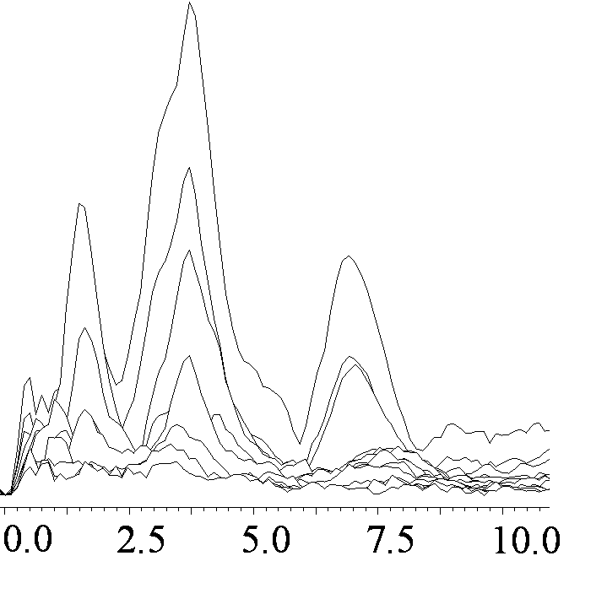
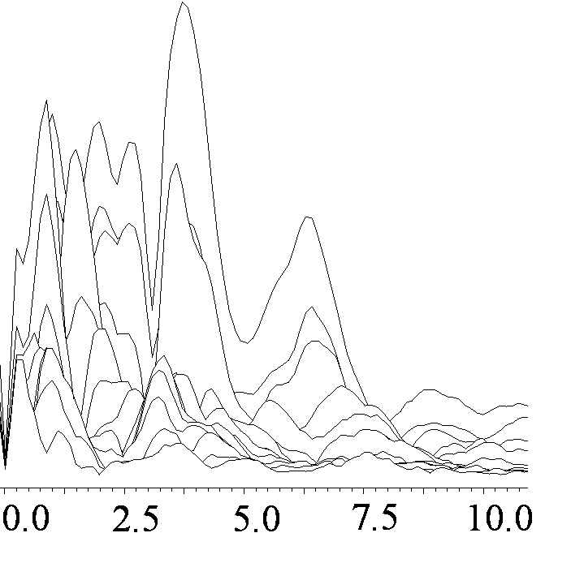
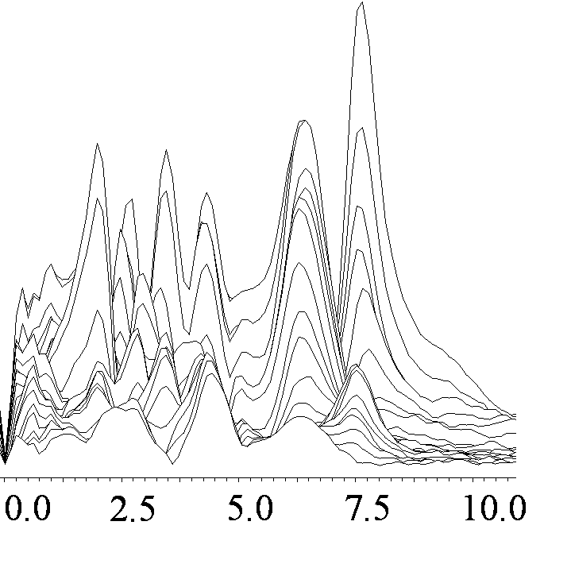

g_{z}
g_{z}

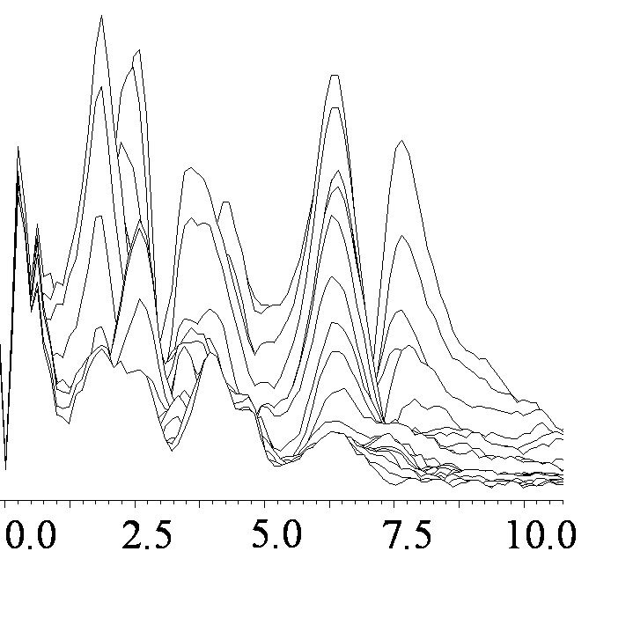

g_{y}
g_{y}

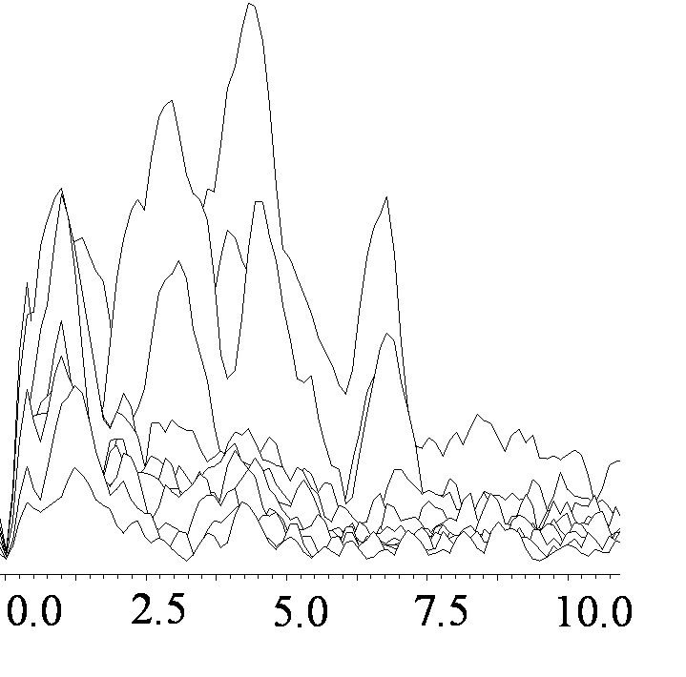
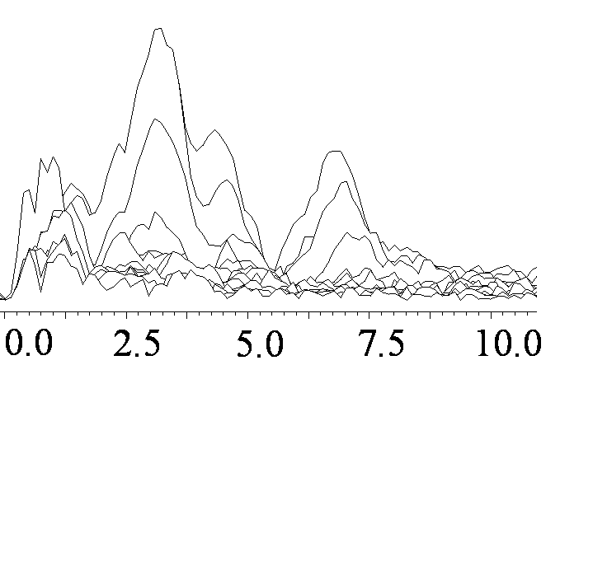

g_{x}
g_{x}

Frequency, MHz

Figure 3

Figure 4

Figure 5

Figure 6

A

Figure 7A

B

Figure 7B

Figure 8
Table 1. Nuclear frequencies of the coordinated nitrogens N1 and N2 in SDX and ARF and evaluated hyperfine and quadrupole couplings at the fields corresponding to the canonical orientations of the g-tensorª

 | N1_{SDX} | N2_{SDX} | N1_{ARF} | N2_{ARF}
Nuclear frequencies at g_{z} (MHz) | (3.6, 2.5, 1.1)  (7.2, 4.3, 2.9) | (4.6, 3.2, 1.4)  (8.5, 5.1, 3.4) | (3.4, 2.5, 0.9)  (7.0, 4.2, 2.8) | (4.4, 3.0, 1.4)  (8.3, 4.9, 3.4)
3⏐Q_{z}⏐ (MHz) | 1.4 | 1.8 | 1.6 | 1.6
ν_{I} (MHz) | 1.06 | 1.06 | 1.0557 | 1.0557
A_{1z} (MHz) | 5.1, 5.7 | 6.4, 6.7 | 4.9, 5.5 | 6.2, 6.5
A_{z} (MHz) | 4.7 | 6.1 | 4.5 | 5.9
Nuclear frequencies at g_{x} (MHz) | (3.2, 2.1, 1.1)  (7.4, 4.2, 3.2) | (4.0, 2.5-2.7, 1.5-1.3)  (8.2, 4.5-4.8, 3.7-3.4) | (3.0, 1.7, 1.3)  (7.0, 3.7, 3.3) | (3.7, 2.5-2.7, 1.2-1.0)  (7.9, 4.6-4.9, 3.3-3.0)
3⏐Q_{x}⏐ (MHz) | 1.0 | 1.0-1.4 | 0.4 | 1.3-1.7
ν_{I} (MHz) | 1.20 | 1.20 | 1.194 | 1.194
A_{1x} (MHz) | 5.0, 5.6 | 5.6, 6.1 | 4.6, 5.4 | 5.5, 6.1
A_{x} (MHz) | 4.7 | 5.0 | 4.3 | 5.2
Nuclear frequencies at g_{y} (MHz) | (2.7, 1.8, 0.9)  (6.5, 3.7, 2.8) | (3.5, 2.3, 1.2)  (7.6, 4.2, 3.4) | (2.7, 1.6, 1.1)  (6.5, 3.5, 3.0) | (3.5, 2.2, 1.3)  (7.6, 4.2, 3.4)
3⏐Q_{y}⏐ (MHz) | 0.9 | 1.1 | 0.5 | 0.9
ν_{I} (MHz) | 1.115 | 1.115 | 1.12 | 1.12
A_{1y} (MHz) | 4.5, 4.9 | 5.4, 5.7 | 4.5, 4.9 | 5.4, 5.7
A_{y} (MHz) | 4.3 | 5.1 | 4.2 | 5.1
A_{iso} (MHz) | 4.6 | 5.4 | 4.4 | 5.4
ªThe position of the isolated peak in the HYSCORE spectra was affected by the value of time τ and by the accuracy of the frequency measurement from the discrete character of the 2D data acquisition. These two factors produce an error in the determination of the cross-peak maximum of the order ~0.1 MHz. Therefore, the frequencies reported above and couplings derived from them are determined with accuracies not less than this error.
3|Q_{z}|, 3|Q_{x},|, 3|Q_{y}| – the quadrupole couplings along g_{z}, g_{x}, g_{y} principal directions of g-tensor.
ν_{I} – ¹⁴N Zeeman frequency for the corresponding HYSCORE spectra measured at g_{z}, g_{x} or g_{y} point of the EPR spectrum (Fig. 1).
A_{1z}, A_{1x}, A_{1y} – hyperfine couplings determined from each dq transition of the two opposite manifolds using the first-order Eq.(1).
A_{z}, A_{x}, A_{y} – second-order corrected hyperfine couplings determined from both of the dq frequencies using Eq.(3).
A_{iso} – isotropic hyperfine coupling calculated as (A_{z}+A_{x}+A_{y})/3 for each nitrogen.

Table 2. Angles characterizing the coordination geometry of imidazole ring from histidine ligands in the bovine soluble Rieske fragment (1RIE.pdb) and BphF (1FQT.pdb) structures
Angles, degrees | Bovine Rieske fragment (1RIE.pdb) |  | BphF (1FQT.pdb)
Angles, degrees | Histidine 1  (His161) | Histidine 2  (His141) | Histidine 1  (His66) | Histidine 2  (His45)
Euler angleª, α | 243 | 211 | 224 | 195
Euler angle, β | 87 | 13 | 109 | 10
Euler angle, γ | 273 | 23 | 262 | 35
Fe-Fe/Fe-N_{δ} | 39 | 52 | 45 | 51
Angle between  imidazole planes | 76 |  | 100

ª Definition of the Euler angles: at the beginning 1_{L}, 2_{L} and 3_{L} axes for both imidazole residues coincide with X, Y, Z. α refers to the residue rotation around its initial 3_{L} (Z) axis, β is the rotation about the new 2_{L} axis, γ is the subsequent rotation around the new (final) 3_{L} axis (Fig. 6).

Supplementary Material

A COMPARATIVE, TWO-DIMENSIONAL ¹⁴N ESEEM CHARACTERIZATION OF REDUCED [2Fe-2S] CLUSTERS IN HYPERTHERMOPHILIC ARCHAEAL HIGH- AND LOW-POTENTIAL RIESKE-TYPE PROTEINS

Sergei A. Dikanovª, Alexander A. Shubin^{b}, Asako Kounosu^{c},
Toshio Iwasaki^{c}, Rimma I. Samoilova^{d}
ªDepartment of Veterinary Clinical Medicine, University of Illinois at Urbana-Champaign,
Urbana IL 61801, USA
^{b}Boreskov Institute of Catalysis, Russian Academy of Sciences, Novosibirsk 630090, Russia
^{c}Department of Biochemistry and Molecular Biology, Nippon Medical School, Sendagi, Bunkyo-ku, Tokyo113-8602, Japan
^{d}Institute of Chemical Kinetics and Combustion, Russian Academy of Sciences,
Novosibirsk 630090, Russia

Comparison of the frequencies manifested in three-pulse and HYSCORE spectra. The nuclear frequencies and couplings for coordinated histidine nitrogens of SDX and ARF summarized in Table 1 are based mainly on analysis of the (+-)-quadrant of the HYSCORE spectra. The prominence of each nuclear transition is different in three-pulse and HYSCORE spectra (Table S1). For instance, two major peaks at 3.7 and 6.3-6.8 MHz in three-pulse ESEEM spectra of SDX and ARF collected near g_{z} (Figs. 2 and S1) belong to the dq transitions of N1_{SDX/ARF}, although the position of the dq₊ line deviated to lower frequencies compared to the HYSCORE spectra (Table S1). On the other hand, the three-pulse spectra of both proteins do not show the dq lines ~4.4-4.6 MHz and ~8.2 MHz from N2 _{SDX/ARF}. The absence of the dq-lines from the N2 in three-pulse spectra is probably a result of their low intensity at this field, incidentally followed from the relative orientation of g-tensor and hyperfine and nqi tensors, which are strictly determined by the protein structure. This peculiarity could lead to an erroneous conclusion about the nitrogen couplings if the analysis was based solely on the three-pulse spectra. There are also other indications of the diversity between three-pulse and HYSCORE spectra that allow us to suggest the additional contribution from nitrogens, other than N1 and N2.
Spectral indications of peptide backbone nitrogens. The hydrogen bonded backbone peptide nitrogens play a significant role as one of the factors modulating redox and chemical properties of catalytic sites in many proteins. Available crystal structures of the Rieske and Rieske-type protein family show the number of peptide backbone nitrogens (from three to six) in each protein suitably located for the formation of hydrogen bonds with sulfur atoms of the cluster or its cysteine ligands [1]. It is proposed that a lower potential cluster has less extensive hydrogen bonding network in the immediate environment. Because the redox potential of ARF is significantly lower than that of SDX, the interaction of reduced Rieske cluster with the peptide nitrogens is an additional important topic for ESEEM spectroscopy.
Three-pulse ESEEM spectra of the reduced plant and vertebrate ferredoxin-type [2Fe-2S] clusters with four cysteine ligands always exhibit lines from the ¹⁴N peptide nitrogens which held some unpaired spin density transferred from the cluster across hydrogen bond bridges. Typical features include a quadrupole triplet at 0.8-1.2, 1.8-2.1, 2.8-3.1 MHz and a dq transition at 4.0-4.4 MHz with orientation dependent intensity [2]. While three-pulse spectra measured at different fields within the EPR spectrum could contain from one to four lines, the orientation dependence of HYSCORE spectra has not been analyzed in detail. HYSCORE spectra measured near g_{y} exhibit cross-peaks in the (++) quadrant at [4.0-4.4; 3.0-3.2] MHz correlating the dq transition with the largest quadrupole transition in opposite electron spin manifolds [3]. Some features observed in three-pulse ESEEM and HYSCORE spectra of the oxygenase-associated, reduced Rieske-type clusters have tentatively been assigned to peptide nitrogens [3,4]. Again, the discussion was limited by the g_{y} direction only. HYSCORE and three-pulse spectra of similar quality obtained at different parts of EPR spectra for SDX and ARF provide us an opportunity to consider this topic in greater detail.
Figs. S1 and 2 show the 2D and stacked plot three-pulse ESEEM spectra of SDX and ARF recorded near g_{z}. One clear difference between these spectra is the number of peaks in the region <3 MHz. There is only one well-pronounced peak at 1.5 MHz in the SDX spectrum, while four different peaks at 2.8, 1.8, 1.5, 1.0 MHz are resolved in ARF spectrum. The intensive lines at 2.8, 1.8 and 1.0 MHz could not be attributed to small variations of the nuclear frequencies of N1_{SDX/ARF} and N2_{SDX/ARF} in the HYSCORE spectra of SDX and ARF (Table 1). These frequencies fulfill the condition of the nqi triplet (the sum of two lower frequencies is equal to the highest frequency) with characteristics similar to those previously reported for the peptide nitrogens. Analogous spectral features are absent in the SDX spectra, providing the first direct spectroscopic evidence for the different hydrogen bond networks around the clusters between these archaeal proteins.
Three-pulse ESEEM spectra of SDX and ARF measured near g_{x} and g_{y} do not provide direct evidence of the peptide contribution because most of their frequencies could be reasonably explained by the contribution of N1_{SDX/ARF} and N2_{SDX/ARF} determined from the corresponding HYSCORE spectra (Figs. 2, S2, and S3, and Table S1). In contrast, the HYSCORE spectra clearly indicate the possible contributions of peptide nitrogens at these orientations.
The low frequency of cross-peaks [4.8, 0.9] MHz (P₁) in the (++) quadrant of the HYSCORE spectrum of SDX at g_{x} (Fig.3) is orientation independent, which is a property of the pure quadrupole frequency. Thus, they could correlate the lowest quadrupole frequency with the dq-transition of the peptide nitrogen. The equivalent peaks are absent in the ARF spectrum, in spite of the very similar characteristics of N2_{SDX/ARF} in both proteins.
On the other hand, the (++)-quadrants in the HYSCORE spectra of SDX and ARF near g_{y} (Fig. 4) demonstrate differences that could not be explained by N1_{SDX/ARF} and N2_{SDX/ARF} only. The cross-peaks at [4.1, 3.5] MHz (P₁) and [4.1, 0.6-1.0] MHz (P₂) in the SDX spectrum correlate frequencies consistent with peptide nitrogens. Although the lines at [4.1, 3.5] MHz formally correspond to the dq-sq correlation from N2_{SDX}, they are absent in the (++) quadrant of the ARF spectrum whereas the (+-) quadrants in the spectra of both proteins show very similar dq-dq and dq-sq correlations from N2_{SDX/ARF} (Table 1). The (++) quadrant of ARF contains the cross-peaks [3.8, 2.8] MHz (P₁) and the extended features at [3.7-3.8, 1.0-1.2] MHz (P₂). These cross-peaks are closely related to dq-sq [3.5, 2.7] MHz and sq-sq [3.5, 1.1] MHz correlations from N1_{ARF}. The equivalent features are absent in the SDX spectrum, although they are in line with the dq-sq [3.7, 2.7] MHz and sq-sq [3.7,0.9] MHz peaks from N1_{SDX}. Based on these arguments, we tentatively assign the discussed features (P₁) and (P₂) in the (++) quadrants of the SDX and ARF spectra to the peptide nitrogens.
The difficulty of the unambiguous assignments of the spectral features from peptide nitrogens in the X-band ESEEM spectra of the reduced Rieske-type clusters is due to a probable masking of their significant portions by highly intense lines from two coordinated N_{δ} located at the same frequencies. This problem can be probably overcome in the experiments at lower microwave frequencies ~2-4 GHz [2]. This band corresponds to the ¹⁴N Zeeman frequency of the order ~0.3-0.35 MHz, which would enhance the ratio A>>ν_{I} for N1 and N2 and decrease the ESEEM depth from them. On the other hand, the cancellation condition A/2~ν_{I} is closer for the peptide nitrogens at this band that would selectively increase their contribution to the ESEEM spectra.

References.
- Hansicker-Wang LM, Heine A, Chen Y, Luna EP, Todaro T, Zhang YM, Williams PA, McRee DE, Hurst J, Stout CD, Fee JA (2003) Biochemistry 42:7303-7317
- Dikanov SA, Tyryshkin AM, Felli I, Reijerse EJ, Hüttermann J (1995) J Magn Reson Ser B 108:99-102
- Dikanov SA, Xun L, Karpiel AB, Tyryshkin AM, Bowman MK (1996) J Am Chem Soc 118:8408-8416
- Shergill JK, Joannou CL, Mason JR, Cammack R (1995) Biochemistry 34:16533-16542

Table S1. Comparison of the frequencies (in MHz) observed in three-pulse ESEEM spectra of the reduced Rieske-type [2Fe-2S] cluster in SDX and ARF with the nuclear frequencies (in MHz) of the coordinated histidine nitrogens (N1_{SDX/ARF}, N2_{SDX/ARF}) determined by HYSCORE spectroscopy

Experiment | SDX, frequencies (MHz) | ARF, frequencies (MHz)
three-pulse (at g_{z}) | 6.8, 3.7, 3.3, 1.5 | 6.3, 3.7, 2.8, 1.8, 1.5, 1.0
N1 by HYSCORE (at g_{z}) | 7.2, 4.3, 3.6, 2.9, 2.5, 1.1 | 7.0, 4.2, 3.4, 2.8, 2.5, 0.9
N2 by HYSCORE (at g_{z}) | 8.5, 5.1, 4.6, 3.4, 3.2, 1.4 | 8.3, 4.9, 4.4, 3.4, 3.0, 1.4
three-pulse (at g_{x}) | 6.7, 4.5, 3.9, 3.4, 2.8, 2.3, 1.0 | 6.7, 4.6, 3.2, 2.4, 1.5, 1.0
N1by HYSCORE (at g_{x}) | 7.4, 4.2, 3.3, 3.2, 2.1, 1.1 | 7.0, 3.7, 3.3, 3.0, 1.7, 1.3
N2 by HYSCORE (at g_{x}) | 8.2, 4.8-4.5, 4.0, 3.7-3.4, 3.2, 2.7-2.5, 1.5-1.3 | 7.9, 4.8-4.5, 3.7, 3.4-3.1, 2.7-2.5, 1.2-1.0
three-pulse (at g_{y}) | 7.5, 6.3, 4.3, 3.5, 2.5, 2.0 | 7.6, 6.3, 4.3, 3.6, 2.6, 1.9
N1 by HYSCORE (at g_{y}) | 6.5, 3.7, 2.8,2.7, 1.8, 0.9 | 6.5, 3.5, 3.0, 2.7, 1.6, 1.1
N2 by HYSCORE (at g_{y}) | 7.6, 4.2, 3.5, 3.4, 2.3, 1.2 | 7.6, 4.2, 3.5, 3.4, 2.2, 1.3

3-pulse: frequencies determined from the position of resolved peaks in the three-pulse spectra (Figs. 2, S1-S3).
N1: six nuclear frequencies from two manifolds for nitrogen N1 in each protein determined by HYSCORE spectroscopy.
N2: six nuclear frequencies from two manifolds for nitrogen N2 in each protein determined by HYSCORE spectroscopy.
Bold: frequencies detected for both 3-pulse and the corresponding HYSCORE spectra within a difference of ~0.2 MHz.
Italic: dq frequencies from N1 in three-pulse ESEEM spectra of SDX and ARF significantly shifted from the frequencies of dq frequencies determined from the HYSCORE spectra.

DX

SDX

ARF
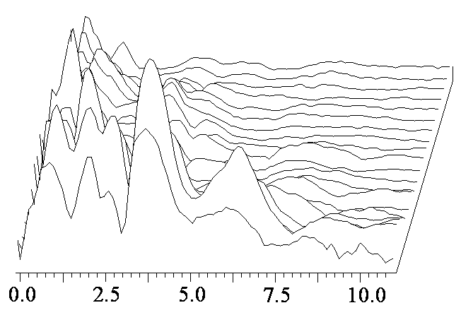

Frequency, MHZ

Figure S1. Two-dimensional plot of three-pulse ESEEM spectra after modulus
FT along time T between the second and third microwave pulses for SDX (344.3
mT, g=2.012) and ARF (343.0 mT, g=2.018) measured near the g_{z} direction. The
initial spectrum corresponds to initial time τ=120 ns and successive spectra are
obtained with increasing steps of 32 ns.

SDX
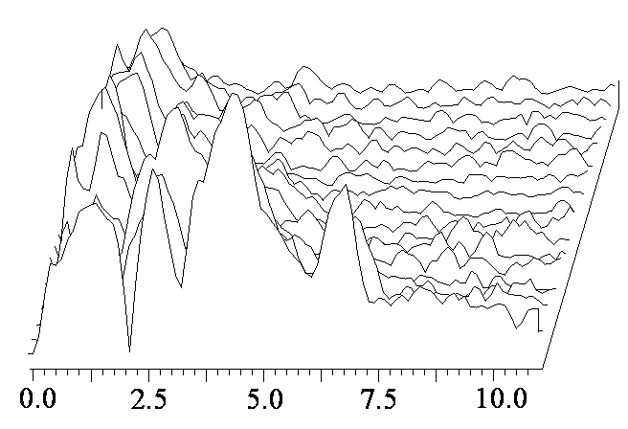

ARF
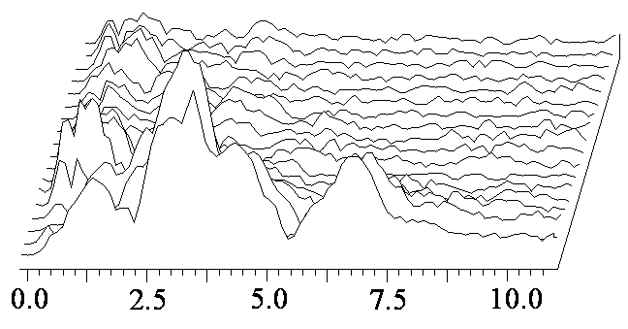

Frequency, MHz

Figure S2. Two-dimensional plots of three-pulse ESEEM spectra after modulus FT along time T between the second and third microwave pulses for SDX (390.5 mT, g=1.774) and ARF (388.0 mT, g=1.784) measured near the g_{x} direction. The initial spectrum corresponds to initial time τ=120 ns and successive spectra are obtained with increasing steps of 32 ns.

SDX
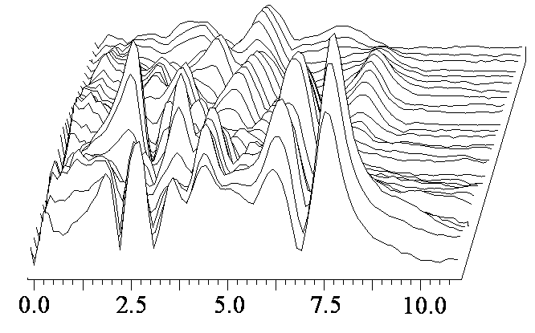

ARF
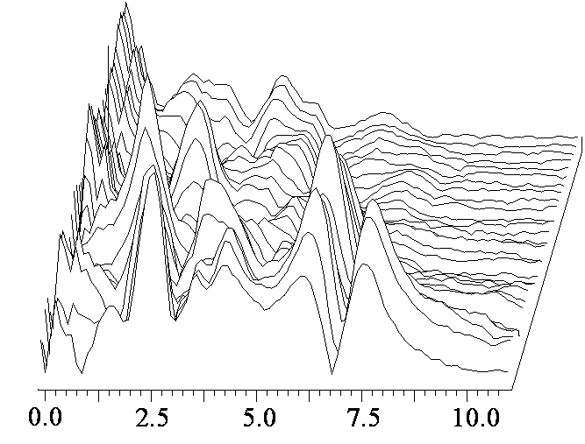

Frequency, MHz

Figure S3. Two-dimensional plots of three-pulse ESEEM spectra after modulus FT along time T between the second and third microwave pulses for SDX (362.3 mT, g=1.91) and ARF (364.0 mT, g=1.903) measured near the g_{y} direction. The initial spectrum corresponds to initial time τ=88 ns and successive spectra are obtained with increasing steps of 16 ns.

