Surface-NMR relaxation and echo of aquifers in geomagnetic field.

Oleg A Shushakov^{1, 2} , Victor M Fomenko¹

1. Institute of Chemical Kinetics and Combustion; Institute of Water and Ecological Problems of Siberian Branch of Russian Academy of Sciences, Novosibirsk, Russia;
2. Novosibirsk State University.

Keywords: surface magnetic resonance sounding (MRS), spin relaxation times, groundwater, aquifer, permeability.

Corresponding author:

Dr. Oleg A. Shushakov
Inst. of Chem. Kinetics and Combustion,
Siberian Branch of Russian Acad. Sci.
3, Institutskaya St., Novosibirsk, 630090-Russia
Email hydro@kinetics.nsc.ru
shushako@kinetics.nsc.ru
Fax +7(3832) 342350
Phone +7(3832) 330392
www.kinetics.nsc.ru/hydro

Abstract.

Macroscopic samples of near-surface water in pores or fractures of rocks down to 100 m and deeper are studied by the measurement of proton relaxation and echo in the Earth’s magnetic field. The excitation and reception of the surface nuclear magnetic resonance (SNMR) signal is accomplished with the help of an antenna, circle or 8-shaped (for the minimization of the outer electromagnetic jamming influence), placed at the surface. The frequency of magnetic resonance in the case being considered amounts to several kilohertz, the dead time of the instrumentation – several milliseconds. Water in extremely small pores of water-resisting rocks (e.g., in argillaceous grounds), chemically bound, crystallization or frozen water has smaller times of spin relaxation and is not registered. The distribution of water concentration with depth is determined by inversion of an integral equation, including the model and measured dependencies of the SNMR signal against the intensity of excitation. The current states-of-the-art of the SNMR sounding and perspectives of this method based on free-induction decay and spin echo detection and relaxation times measurement are presented. Free-induction decay T₂* equal to 60 milliseconds, spin-echo T₂ equal to 220 milliseconds, and inversion-recovery T₁ equal to 700 milliseconds relaxation times have been measured for medium to coarse-grained sand aquifer. Microscopic characteristics of the aquifer: longitudinal relaxivity (7 10⁻³ cm/s), transverse relaxivity (3.5 10⁻² cm/s), and local magnetic field gradient (2 10⁻² Gauss/cm) have been estimated using experimental data. The importance of spin relaxation and echo measurement is emphasized for obtaining the information about the microstructure of pores and fractures, as well as filtration properties of aquifers and diamagnetic, hydrocarbon, and paramagnetic contamination.
1. Introduction

Soundings using surface NMR in the Earth’s magnetic field proved to be a rapid and effective method of measuring subsurface movable water content (effective or producible porosity), water-saturated rock pore size (or permeability) estimation, diamagnetic contamination (or salinity) detection. Earlier study [1] discusses some aspects of the surface nuclear magnetic resonance (SNMR) sounding signal of bulk water detected from the ice surface of Ob reservoir near Novosibirsk. The SNMR experiments of bulk water are useful for calibration and testing of the method. Nevertheless, most of the SNMR application is devoted to near surface porous or fractured aquifers sounding. The distribution of water saturation down to depth of 100 m and more is determined by inversion of an integral equation, including model and measured SNMR signal amplitude [2]. As it was partly reported earlier in [3], investigation of spin relaxation times set: transverse inhomogeneous spin-spin T₂*, transverse spin-spin T₂, and longitudinal spin-lattice T₁ is important for both obtaining the information about the microstructure of pores and diamagnetic, paramagnetic, and hydrocarbon contamination detection. A novel SNMR technique allowed T₂*, T₂, T₁ measurement for medium to coarse-grained sand aquifer using one or two-pulse (spin-echo or inversion-recovery) sequences. The effect of pore size distribution, permeability, and groundwater contamination on SNMR relaxation is considered both theoretically and experimentally.

2. Basic principles of the SNMR method

Figure 1 sketches the typical scheme of SNMR groundwater sounding and contamination detection. The method is based on the principle of observation of the proton magnetic resonance in the geomagnetic field of hydrogen nuclei of groundwater molecules.
In the Earth's magnetic field a macroscopic magnetization of a unite volume in thermal equilibrium is described by the equation [4]:
(1), where n(r) is the number of magnetic nuclei per unit volume, S=1/2 is the nuclear spin,and k are Planck and Boltzmann constants, and T is the temperature.
After the pulse, which generates the oscillating field , in resonant case the frequency ω is equal to the Larmor precession frequency in geomagnetic field $ω _{L}= γ_{H}⋅H_{0}$, the vector is tilted away from the vector by the angle:
(2), where is the gyromagnetic ratio of protons, is the alternating field component that is normal to and is the pulse duration.
The emf induced in the loop by the magnetic field of groundwater nuclear magnetization, is determined by the equation [1]
$E_{0}(Q) = \left(ω/I\right)\int_{V}{M_{}}(r)H_{1⊥(r)dV(r) }$ (3), where , I is the amplitude of the excitation current, is the excitation pulse intensity (pulse moment), and is the NMR signal amplitude that is measured.
The depth of water-saturated layers can be determined from the NMR signal amplitude dependence on the excitation-current pulse intensity (pulse moment) .

3. Effect of formation conductivity

The time-harmonic electric and magnetic fields and of the loop and groundwater magnetic nuclei are changed in amplitude and phase due to screening effect of induced currents in the source-free media of magnetic permeability μ, dielectric permittivity ε and conductivity σ.
Assume the wire loop to be placed at the origin of a cylindrical coordinate system (r, ϕ, z), so that the wire is laid along the circle in the plane z = 0. A homogeneous and uniform formation with conductivity fills the half-space z > 0, the air conductivity being = 0 (Fig. 2). In the half-space z > 0, the magnetic field of the loop has the form [5, 6]

$H_{1z}(r)=IR_{0} \int_{0}^{∞}{\frac{m^{2}}{m+u} }e^{−u z} J_{1}(R_{0}m)⋅J_{0}(rm) dm$ (4), $H_{1r}(r)=IR_{0} \int_{0}^{∞}{\frac{mu}{m+u} }e^{−u z} J_{1}(R_{0}m)⋅J_{1}(rm) dm$ (5), where and J are Bessel functions.
The excitation field can be regarded as a complex value in expression (2) in the presence of formation conductivity. Equations 2 and 3 can be rewritten as

(6),

(7).
The NMR signal also is a complex value possessing amplitude and phase. The vector model of NMR signal formation gives the expression [5, 6]

$E_{0}(Q) = \left(ω/I\right)\int_{V}{}$ (8).

The surface NMR signal of the loop over the horizontally stratified earth was studied in [7].

4. SNMR relaxation and permeability of porous rock and soil

Darcy’s law defines the permeability k of a porous medium that governs the flow rate u of a viscous fluid:
u = k P/ (9), where P is the pressure drop across the sample,  is the fluid viscosity.
For a liquid, the magnetic relaxation process is coupled with diffusion of the liquid molecules:
∂M_{x}/∂t = D ∆(M_{x} - M_{x0}) - M_{x}/T_{2bulk} + γ (M X H)_{x} (10), ∂M_{y}/∂t = D ∆(M_{y} - M_{y0}) - M_{y}/T_{2bulk} + γ (M X H)_{y} (11), ∂M_{z}/∂t = D ∆(M_{z} - M_{z0}) - M_{z}/T_{1bulk} + γ (M X H)_{z} (12),
where D is the self-diffusion coefficient, T_{1bulk} and T_{2bulk} are the longitudinal and transverse relaxation times of bulk water.
In the presence of inhomogeneous field the problem has been treated by Hahn [8], by Das and Saha [9], by Carr and Purcell [10], by Torrey [11], by Robertson [12], and others. In the rotating frame (‘) and with the exponential relaxation factored out of the magnetization [11], it is:
∂U/∂t = D ∆U - i γ G z U (13), where, G is the field gradient, U = M’_{x} + i M’_{y}, (n∙ M’) = 0 on the boundary, n is the unit outward normal directed from the boundary surface.
As a result, the attenuation A by diffusion following a 90º pulse [8-12]:
A_{ind} = exp(-D γ² G² t³/3) (14), the attenuation of spin-echo amplitude following a 90º- 180º pulse sequence is
A_{echo} = exp(-D γ² G² t³/12) (15).
Because NMR lifetimes are related to the lengths that characterize the pore space, magnetic resonance is a valuable, noninvasive technique for estimating the permeability of a porous medium. In porous media the fluid’s bulk NMR relaxation processes are overwhelmed by the influence of the pore-grain interface, where the proton magnetization decays rapidly due either to the presence of paramagnetic impurities or to the hindered rotation of H₂O molecules. The decay is usually described in terms of a phenomenological killing strength ρ [13-15].
The magnetization satisfies the diffusion equation (10-12) with the boundary conditions:
D (n∙ M’_{x}) + ρ₂ M’_{x} = 0 (16), D (n∙ M’_{y}) + ρ₂ M’_{y} = 0 (17),
D (n∙ M’_{z}) + ρ₁ M’_{z} = 0 (18).
In the application of the NMR technique to the study of the properties of fluids in porous media the theoretical studies of Korringa [13] and others resulted in a model of relaxation of spin polarization of protons in a hydrogenous fluid in a pore of a solid.
1/T₁ = 1/T_{1bulk} +(S/V)λ/T_{1surface} (19), where T_{1bulk} is the longitudinal relaxation time of bulk water, S/V is the pore surface area to volume, and λ is the thickness of the surface monolayer which by itself would relax with time constant T_{1surface}. For the equation (19) to hold, diffusion must be fast enough to keep the magnetization uniform across the pore as decay progresses. Equation (19) can be rewritten as:
1/T₁ = 1/T_{1bulk} +ρ₁ S/V (20), where ρ₁ is the longitudinal relaxivity of the surface equal to λ/T_{1surface}.
There are three NMR transverse relaxation (T₂) mechanisms for pore fluids in the pore space of a rock:
- relaxation by bulk fluid processes;
- grain surface relaxation mechanism;
- relaxation by molecular diffusion in magnetic fields gradients (15).
1/T₂ = 1/T_{2bulk} + ρ₂ S/V + (γ G t)² D /12 (21), where ρ₂ is the transverse relaxivity (16, 17).
For inhomogeneous transverse relaxation (T₂*) there are four NMR relaxation mechanisms for fluids in the pore space of a rock:
- relaxation by bulk fluid processes;
- grain surface relaxation mechanism;
- relaxation by molecular diffusion in magnetic fields gradients;
- relaxation due to local magnetic field inhomogeneity.
1/T*₂ = 1/T*_{2bulk} + ρ₂ S/V + (γ G t)² D /3 + γ G a (22), where a is a grain radius.
Senturia and Robinson [14] and Brownstein and Tarr [15] have considered a model to relate the relaxation time of a liquid-filled porous solid to its geometrical and physical properties. Based on such models, Seevers [16], Timur [17-20], Loren and Robertson [21, 22], Kenyon et al. [23, 24], and others estimated permeability of porous rock from NMR measurements. Kenyon et al. [23, 24] estimated permeability better by ⁴T₁² (explained in terms of presence of throats between pores), rather than by Seevers’ [16] classic estimator T₁², where  is the porosity, T₁ is the longitudinal relaxation time.
Equations (9-22) exhibit different correlation of rock and core permeability and spin relaxation times T₂*, T₂, T₁.

5. Experimental and test sites

The SNMR experiments were performed using the Hydroscope-3 equipment made in the Institute of Chemical Kinetics and Combustion of Siberian branch of the Russian Academy of sciences, Novosibirsk. The technique allows maximal pulse moment up to 20000 A*ms (at 40 ms pulse duration, Fig. 2) and possibility of two-pulse sequence using the battery capacitance 0.2 F.
Figure 1 shows the lithological log of well # 37 (Novosibirsk) and geophysical logs (resistivity, and gamma-ray). There was sandy clay aquitard from 0.5 to 21.8 m, medium to coarse-grained sand aquifer from 21.8 to 39.6 m underlain by clay-rich aquitard from 39.6 to 63 m. The groundwater mineralization (total dissolved solids) at the medium-to-coarse deposit was 0.46 g/l, dissolved Fe ions concentration was about 0.7 mg/l (including Fe²⁺ - 0.3 mg/l). Water transmissivity was 379 m²/day. The resonant frequency of protons measured both by the proton magnetometer and by the surface NMR technique was 2514 Hz. The 100 m diameter circular loop and eight-shaped loop [25] had been used at the # 37 well.

6. Results and discussion

Figure 1 compares the surface-NMR water content (%) with the strata log, the resistivity, and gamma-ray logs for well # 37 (Novosibirsk). Shown at the Figure 1 SNMR free groundwater content was obtained using the inversion procedure based on the conjugate-gradient complex-projection algorithm. The strata resolution amounts up to about 1 m at shallower depths and to 10 m and more at close to maximal prospecting depths (down to 100 m and deeper) [2].
The surface NMR amplitude and especially phase are sensitive to subsurface material lower resistivity caused by salinity via effect of electromagnetic screening [5–7]. Figures 2, 3 compare the surface NMR amplitude and phase measured at the well # 37 by 100 m diameter circular loop with calculated for well # 37 resistivity log (Fig. 1), and for 100 ohm-m of resistivity half space. The porosity  = 25 % (as well as saturation of groundwater with depth distribution) can be estimated sing inversion procedure (Fig. 1-3).
Figures 4 - 7 exemplify the SNMR FID and spin-echo amplitudes versus time and pulse moment for different time delay between pulses for 16 ms of the first pulse duration and 34 ms of the second pulse duration (well # 37, Novosibirsk). We are not aware of any other surface NMR experiments that have detected spin echoes of subsurface water.
The spin-echo 90º-180º-pulse sequence has been used for transverse relaxation time T₂ measurement [8]. Standard inversion-recovery 180º-90º-pulse sequence has been used for longitudinal relaxation time T₁ measurement [26]
Figures 8, 9 specify the transverse and longitudinal spin relaxation times (T₂*, T₂, T₁), published earlier in [3], using the novel technique for the medium to coarse-grained sand aquifer at the well # 37, Novosibirsk. The relaxation time T₂* measured at the Figs. 8 differs from published earlier [27] phenomenological correlation between inhomogeneous spin-spin relaxation time T₂* and pore size. In [27] spin relaxation due to paramagnetic impurities was not taken into account. Figures 8, 9 within experimental accuracy exhibit exponential behaviour of relaxation curves with decay times T₂* = 60 ms, T₂ = 220 ms, and T₁ = 700 ms. Spin-spin relaxation times T₂, T₂* measured did not vary with time, indicating that third (diffusion) term in equations (20, 21) must be approximately zero for this aquifer. Therefore longitudinal relaxivity ρ₁ equal to 7 10⁻³ cm/s and transverse relaxivity ρ₂ equal to 3.5 10⁻² cm/s as well as local field gradient G equal to 2 10⁻² Gauss/cm can be estimated using T_{1bulk} = 1.4 s, T_{1bulk} = 1 s [3], a = 2.5 10⁻² cm. Using diffusion coefficient D = 1.3 10⁻⁵ cm²/s for water at 277 K one can estimate the diffusion term  4 10⁻² s⁻¹ ( 1 s⁻¹) in equations (20, 21) that confirm earlier approximation based on the experimental data.

7. Conclusion

A novel SNMR technique allowed T₂*, T₂, T₁ measurement for medium to coarse-grained sand aquifer using one or two-pulse (spin-echo or inversion-recovery) sequences. Free-induction decay T₂* equal to 60 milliseconds, spin-echo T₂ equal to 220 milliseconds, and inversion-recovery T₁ equal to 700 milliseconds relaxation times have been measured. Such microscopic characteristics of the aquifer as longitudinal relaxivity ρ₁ = 7 10⁻³ cm/s, transverse relaxivity ρ₂ = 3.5 10⁻² cm/s, and local magnetic field gradient G = 2 10⁻² Gauss/cm have been estimated using experimental data.

Acknowledgements

The authors are grateful to Eugene Kalneus, Eiichi Fucushima, Vladimir Novoselov, and Victor Kuskovsky for their assistance in the experiments and fruitful discussion, to the reviewers for significant improvement of the manuscript.

References.

[1] Trushkin D.V., Shushakov O.A., Legchenko A.V.: Appl. Magn. Res., 5, 399 (1993).
[2] Legchenko A.V., Shushakov O.A.: Geophysics, 63, 75 (1998).
[3] Shushakov O.A.: Magn. Res. Imaging, 14, 959 (1996).
[4] Abragam A.: The principles of nuclear magnetism, Oxford University press 1961.
[5] Shushakov O.A.: Geophysics, 61, 998 (1996).
[6] Trushkin D.V., Shushakov O.A., Legchenko A.V.: Geoph. Prospecting, 43, 623 (1995).
[7] Shushakov O.A., Legchenko A.V.: Geol. i Geofizika (in Russian), 35, 161 (1994).
[8] Hahn E. L.: Phys. Rev., 80, 580 (1950).
[9] Das T.P., Saha A.K.: Phys. Rev., 93, 749 (1954).
[10] Carr H.Y., Purcell E.M.: Phys. Rev., 94, 631 (1954).
[11] Torrey R.C.: Phys. Rev., 104, 563 (1956).
[12] Robertson B.: Phys. Rev., 151, 273 (1966).
[13] Korringa J.: Bull. Amer. Phys. Soc. (Ser. II), 1, 216 (1956).
[14] Senturia S. D., Robinson J. D.: Soc. Petr. Eng. Journ., 249, 237 (1970).
[15] Brownstein K.R., Tarr C.E.: Phys. Rev. A, 19, 2446 (1979).
[16] Seevers D.O.: SPWLA Trans., Paper L (1966).
[17] Timur A.: SPWLA Trans., Paper K (1968).
[18] Timur A.: Log Analyst, 10, 3 (1969).
[19] Timur A.: Journ. Petr. Tech, 775 (June 1969).
[20] Timur A.: SPWLA Trans., Paper N (1972).
[21] Loren J.D., Robertson J.D.: Soc. Petr. Eng. Journ., 249, 268 (1970).
[22] Loren J.D.: Journ. Petr. Tech, 923 (Aug. 1972).
[23] Kenyon W.E, Day P.I., Starley C., Willemsen J.F.: SPE 15643 (1986).
[24] Kenyon W.E, Day P.I., Starley C., Willemsen J.F.: SPE Formation Evaluation, 633 (1988).
[25] Trushkin D.V., Shushakov O. A., Legchenko A.V.: Geoph. Prospecting, 42, 855 (1994).
[26] Fukushima E., Roeder S.B.W. Experimental pulse NMR. A nuts and bolts approach, Addison-Wesley publishing Co 1994.
[27] Schirov M.D., Legchenko A.V., Creer J.G.: Exploration Geoph., 22, 333 (1991).
Figure captions

Figure 1. Surface-NMR water content (%) compared with the strata log, the resistivity, and gamma-ray logs for borehole # 37 (Novosibirsk) site.
Figure 2. Comparison of the surface NMR amplitude measured at borehole # 37 by 100 m diameter circular loop with calculated for Figure 1 resistivity log, and for 100 ohm*m of resistivity half space.
Figure 3. Comparison of the surface NMR phase measured at borehole # 37 by 100 m diameter circular loop with calculated for Figure 1 resistivity log, and for 100 ohm*m of resistivity half space.
Figure 4. FID and spin-echo amplitudes (in Microvolts) versus time (in milliseconds) and pulse moment (in Amps*milliseconds) for 16 ms (first pulse duration) – 100 ms (delay between pulses) – 34 ms (second pulse duration) pulse-sequence for borehole # 37 (Novosibirsk).
Figure 5. FID and spin-echo amplitudes (in Microvolts) versus time (in milliseconds) and pulse moment (in Amps*milliseconds) for 16 ms (first pulse duration) – 225 ms (delay between pulses) – 34 ms (second pulse duration) pulse sequence for borehole # 37 (Novosibirsk).
Figure 6. FID and spin-echo amplitudes (in Microvolts) versus time (in milliseconds) and pulse moment (in Amps*milliseconds) for 16 ms (first pulse duration) –350 ms (delay between pulses) – 34 ms (second pulse duration) pulse sequence for borehole # 37 (Novosibirsk).
Figure 7. FID amplitude (in Microvolts) versus time (in milliseconds) and pulse moment (in Amps*milliseconds) for 16 ms pulse duration for borehole # 37 (Novosibirsk).
Figure 8. FID and spin-echo amplitudes for 16 ms first pulse duration (90º), and 34 ms second pulse duration (180º) pulse sequence with delays between pulses from 100 ms (1) to 700 ms (13) respectively with 50 ms time interval. The transverse relaxation times measured are T₂* = 60 ms and T₂ = 220 ms. Borehole # 37 (Novosibirsk).
Figure 9. FID amplitude versus the time after the second pulse for 32 ms of the first pulse duration (180º), and 18 ms of the second pulse duration (90º) pulse sequence. The longitudinal relaxation time measured is T₁ = 700 ms. Borehole # 37 (Novosibirsk)

Figure 1. Surface-NMR water content (%) compared with the strata log, the resistivity, and gamma-ray logs for borehole # 37 (Novosibirsk) site.

Figure 2. Comparison of the surface NMR amplitude measured at borehole # 37 by 100 m diameter circular loop with calculated for Figure 1 resistivity log, and for 100 ohm*m resistivity half space.

Figure 3. Comparison of the surface NMR phase measured at borehole # 37 by 100 m diameter circular loop with calculated for Figure 1 resistivity log, and for 100 ohm*m resistivity half space.

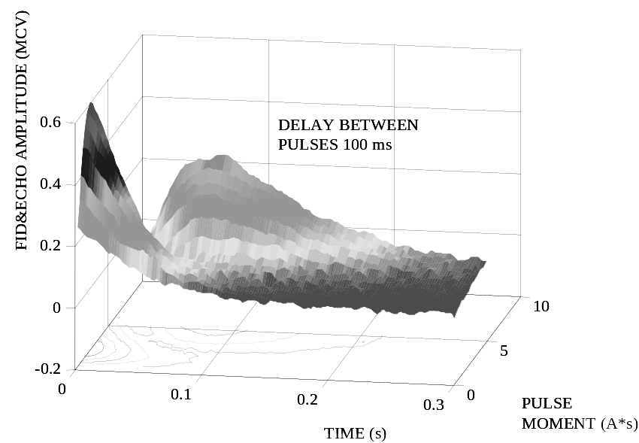
Figure 4. Surface and contour plot of FID and spin-echo amplitudes (in Microvolts) versus time (in seconds) and pulse moment (in Amps*seconds) measured at 16 ms (first pulse duration) – 100 ms (delay between pulses) – 34 ms (second pulse duration) pulse-sequence for borehole # 37 (Novosibirsk).

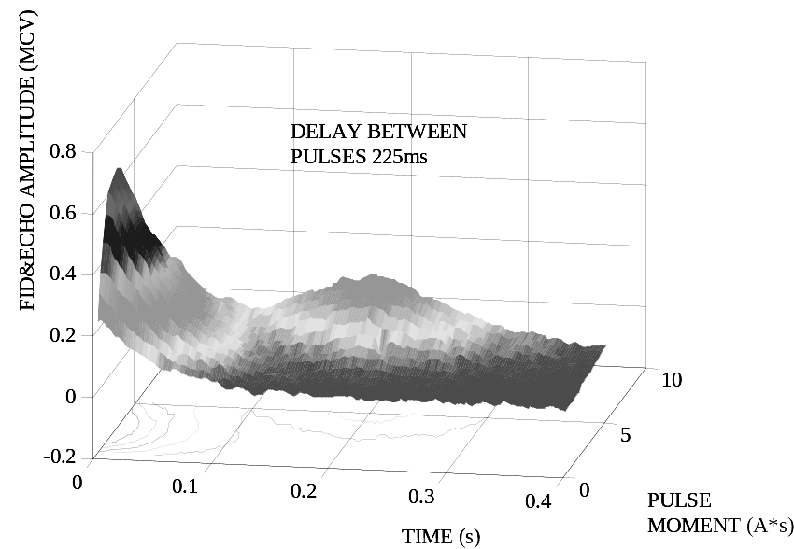
Figure 5. Surface and contour plot of FID and spin-echo amplitudes (in Microvolts) versus time (in seconds) and pulse moment (in Amps*seconds) measured at 16 ms (first pulse duration) – 225 ms (delay between pulses) – 34 ms (second pulse duration) pulse sequence for borehole # 37 (Novosibirsk).

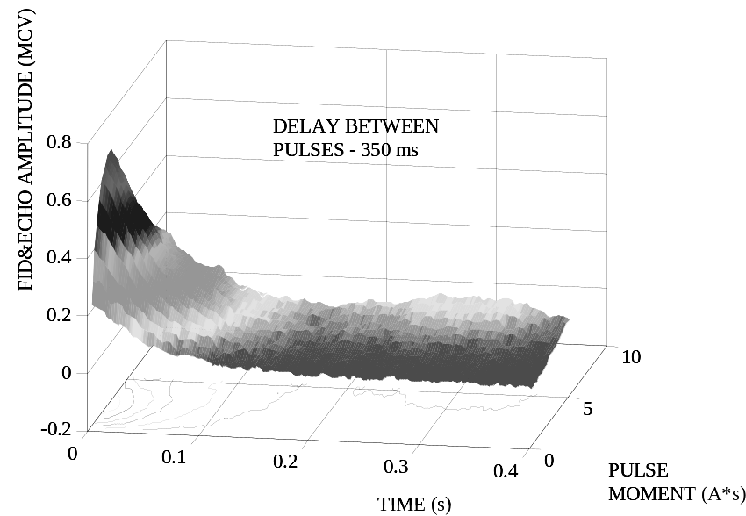
Figure 6. Surface and contour plot of FID and spin-echo amplitudes (in Microvolts) versus time (in seconds) and pulse moment (in Amps*seconds) measured at 16 ms (first pulse duration) –350 ms (delay between pulses) – 34 ms (second pulse duration) pulse sequence for borehole # 37 (Novosibirsk).

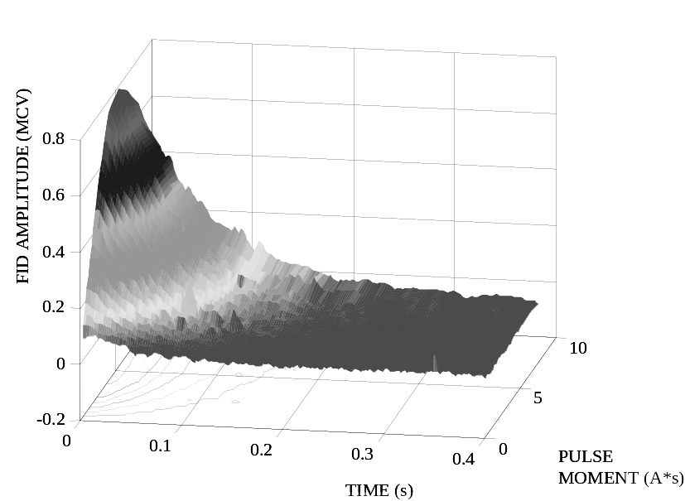
Figure 7. Surface and contour plot of FID amplitude (in Microvolts) versus time (in seconds) and pulse moment (in Amps*seconds) measured at 16 ms pulse duration for borehole # 37 (Novosibirsk).

Figure 8. FID and spin-echo amplitudes for 16 ms first pulse duration (90º), and 34 ms second pulse duration (180º) pulse sequence with delays between pulses from 100 ms (1) to 700 ms (13) respectively with 50 ms time interval. The transverse relaxation times measured are T₂* = 60 ms and T₂ = 220 ms. Borehole # 37 (Novosibirsk).

Figure 9. FID amplitude versus the time after the second pulse for 32 ms of the first pulse duration (180º), and 18 ms of the second pulse duration (90º) pulse sequence. The longitudinal relaxation time measured is T₁ = 700 ms. Borehole # 37 (Novosibirsk).

